##### A Project Report

##### on

**Image Transfer Reality Using Augmented Reality & Artificial Intelligence**

***Submitted to***

**JAWAHARLAL NEHRU TECHNOLOGICAL UNIVERSITY, ANANTHAPURAMU**

*In partial fulfillment of requirement for the award of the degree of*

**Bachelor of Technology**

In

**Computer Science & Engineering**

*By*

#### N. Sai Yaswanth Reddy (17F11A0573)

**N. Venkatesh (17F11A0567)**

**R. Subramanyam (17F11A0594)**

*Under the esteemed Guidance of*

## Mr. N. Yendukondalu

## Assistant Professor



**DEPARTMENT OF COMPUTER SCIENCE AND ENGINEERING**

NARAYANA ENGINEERING COLLEGE :: GUDUR

**(An ISO 9001:2008 Certified Institution, Approved by AICTE New Delhi &Permanently Affiliated to JNTUA, Ananthapuramu )**

**Accredited with “A” Grade by NAAC**

**Dhurjati Nagar, Gudur – 524101, SPSR Nellore Dt., A.P., India**

**www.necg.ac.in**

**2017-2021**

NARAYANA ENGINEERING COLLEGE :: GUDUR

**(An ISO 9001:2008 Certified Institution, Approved by AICTE New Delhi &Permanently Affiliated to JNTUA, Ananthapuramu )**

**Accredited with “A” Grade by NAAC**

## DEPARTMENT OF COMPUTER SCIENCE AND ENGINEERING



**BONAFIDE CERTIFICATE**

This is to certify that the project entitled **IMAGE TRANSFER REALITY USING AUGMENTED REALITY & ARTIFICIAL INTELLIGENCE** that is being submitted by **N.Sai Yaswanth Reddy (17F11A0573), N.Venkatesh (17F11A0567), R.Subramanyam (17F11A0594)** in partial fulfillment of the requirements for the award of degree of **Bachelor of Technology** in **COMPUTER SCIENCE AND ENGINEERING** to JNTUA Ananthapuramu is recorded to be the bonafied work carried out by him/her under my guidance and supervision.

**PROJECT GUIDE HEAD OF THE DEPARTMENT**

Mr. N. Yedukondalu Dr. P. Venkateswara Rao, Ph D

Assistant Professor. Professor.

**INTERNAL EXAMINER EXTERNAL EXAMINER**

**ACKNOWLEDGEMENT**

We extremely thankful to **Dr.P.Narayana**, the **Founder Chairman** of **Narayana Group** for his good initiation starting technical institution in Gudur like rural area for helping economically poor students. We also thankful to **Mr.K.Puneeth**, the **Chairman** of **Narayana Group** for providing the infrastructural facilities to work in, without this the work would not have been possible.

We would like to express our deep sense of gratitude to **Dr.V.Ravi Prasad, Principal, Narayana Engineering College, Gudur** for his continuous effort in creating a competitive environment in our college and encouraging throughout this course.

We would like to convey our heartfelt thanks to **Dr.P.Venkateswara Rao, Professor & HOD** of Computer Science and Engineering for giving the opportunity to embark up on this topic and for her continues encouragement throughout the preparation of the project.

We would like to thank our guide **Mr. N. Yedukondalu, Assistant Professor**, Department of CSE for his/her invaluable guidance, constant assistance, support, endurance and constructive suggestions for the betterment of the project.

We also wish to thank all the **staff members** of the Department of Computer Science & Engineering for helping us directly or indirectly in completing this project successfully.

Finally we are thankful to our **parents and friends** for their continued moral and material support throughout the course and in helping us to finalize the report.

#### N. Sai Yaswanth Reddy(17F11A0573)

#### N.Venkatesh(17F11A0567)

**R.Subramanyam(17F11A0594)**

**DECLARATION**

We hereby declare that the project entitled **Image Transfer Reality Using Augmented Reality & Artificial Intelligence** has been done by us under the guidance of **Mr. N. YEDUKONDALU, Assistant professor** Department of Computer Science & Engineering. This project work has been submitted to **NARAYANA ENGINEERING COLLEGE, GUDUR** as a part of partial fulfillment of the requirements for the award of degree of **Bachelor of Technology**.

We also declare that this project report has not been submitted at any time to another institute or University for the award of any degree.

#### N.Sai Yaswanth Reddy(17F11A0573)

**N.Venkatesh(17F11A0567)**

**R.Subramanyam(17F11A0594)**

**Place: Gudur**

**Date:**

|  |  |  |
| --- | --- | --- |
| S.NO | CONTENT | PAGE NO |
| I | ABSTRACT | i |
| II | LIST OF FIGURES | ii |
| III | LIST OF TABLES | iii |
| IV | LIST OF ABBREVIATIONS | iv |
| 1 | INTRODUCTION | 1 |
| 2 | FEASIBILITY STUDY2.1 Technical Feasibility2.2 Economical Feasibility2.3 Social Feasibility | 5 |
| 3 | SYSTEM ANALYSIS3.1 System Study3.2 Advantages3.3 Augmented Reality3.4 Methodology3.4.1 SIFT Algorithm 3.4.1.1 Scale-space peak selection 3.4.1.2 Finding keypoints 3.4.1.3 Keypoint Localization3.4.1.4 Orientation Assignment3.4.1.5 Keypoint Matching3.5 Input Design3.6 Output Design3.7 System Requirements | 7 |
| 4 | SOFTWARE ENVIRONMENT4.1 Introduction to Python4.2 Installation of Python4.3 Installation of Node4.4 Installation of Photoshop4.5 Installation of Expo App4.6 Installation of Clip Drop Application | 20 |

## INDEX

## 

|  |  |  |
| --- | --- | --- |
| 5 | SYSTEM DESIGN5.1 System Architecture5.1.1 Mobile Architecture5.1.2 PlugIN Architecture5.2 DFD Diagram5.3 UML Diagrams5.3.1 Use Case Diagram5.3.2 Class Diagram5.3.3 Sequence Diagram5.3.4 Activity diagram5.3.5 Deployment Diagram | 45 |
| 6 | IMPLEMENTATION6.1 Modules6.1.1 BASNET6.1.2 OpenCV SIFT Method6.1.3 PhotoShop6.1.4 Libraries | 54 |
| 7 | SYSTEM TESTING7.1 Unit Testing7.2 Integration Testing7.3 Acceptance Testing | 56 |
| 8 | RESULTS & OUTPUTS | 59 |
| 9 | CONCLUSION | 64 |
| 10 | BIBILOGRAPHY | 65 |

## ABSTRACT

The massive technological advancements around the world have created significant challenging competition among companies where each of the companies tries to attract the customers using different techniques. One of the recent techniques is Augmented Reality (AR). The AR is a new technology which is capable of presenting possibilities that are difficult for other technologies to offer and meet. Augment Reality tool that can capture images of real-world objects and add them to a computer program in a few seconds. AR Copy Paste allows users to take a photo of an object in the real world and drop the image into a desktop computer program with a few simple actions on their smart phone. The app uses augmented reality (AR) and machine learning technology to detect objects in the real world and isolate the image so that the background is automatically removed. Users then move the smart phone over their computer screen to paste the object image into a compatible computer program, such as Photo shop or In Design.

i

## LIST OF FIGURES

|  |  |  |
| --- | --- | --- |
| **FIG.NO** | **NAME** | **PAGE NO** |
| 1 | Comparison of model size and performance | 3 |
| 2 | Augmented Reality | 10 |
| 3 | Drag and Drop | 11 |
| 4 | Drop Component Interface | 12 |
| 5 | SIFT Features | 13 |
| 6 | DOG | 14 |
| 7 | Finding KeyPoints | 15 |
| 8 | Graph Orientation | 17 |
| 9 | System Architecture | 45 |
| 10 | Mobile Architecture | 45 |
| 11 | PlugIN Server Architecture | 46 |
| 12 | Data Flow Diagram | 47 |
| 13 | Use Case Diagram | 49 |
| 14 | Class Diagram | 50 |
| 15 | Sequence Diagram | 51 |
| 16 | Activity Diagram | 52 |
| 17 | Deployment Diagram | 53 |
| 18 | Path File | 59 |
| 19 | Path File | 59 |
| 20 | App Execution | 60 |
| 21 | QR Code Generator | 60 |
| 22 | App Interface | 61 |
| 23 | Server Execution | 61 |
| 24 | Actual Output | 62 |
| 25 | Expected Output | 62 |
| 26 | Expected Output | 63 |
| 27 | Practical Output | 63 |

ii

**LIST OF TABLES**

|  |  |  |
| --- | --- | --- |
| **TABLE NO** | **NAME** | **PAGE NO** |
| 1 | Test whether the passivity system is able to Capture the Image | 58 |
| 2 | Test by Removing the background with image | 58 |
| 3 | Test when the without background image drag on the area | 58 |
| 4 | Test by server IP address match on the mobile app and machine | 58 |
| 5 | Test when the copying without background images on the desktop in paste same image | 58 |

iii

**LIST OF ABBREVATIONS**

1. AR - Augmented Reality
2. SIFT - Scale Invariant Feature Transform
3. DOG - Difference of Gaussian
4. OpenCV - Open Computer Vision

iv

**1.INTRODUCTION**

The AR is another innovation which is fit for introducing potential outcomes that are hard for different advancements to offer and meet. These days, various increased reality applications have been utilized in the business of various types and spread everywhere on the world .AR Copy Paste permits clients to snap a picture of an item in reality and drop the picture into a personal computer program with a couple of basic activities on their cell phone. The application utilizes increased reality (AR) and AI innovation to distinguish objects in reality and seclude the picture with the goal that the foundation is naturally eliminated.

Technology has become embedded in education and the results indicate a positive impact on learning and teaching styles. According to Shapley et al, lessons that are supported by technology will lead to more innovative forms of teaching and learning. This is because the use of technology involves real-world problems, current informational resources, simulations of concepts, and communication with professionals in the field. In addition, learning using technology is believed to complement the traditional forms of teaching and learning.

The integration of technology tools into the curriculum is becoming part of good teaching (Pierson, 2001). Teachers not only have to spend a good deal of personal time working with computers but also should have a high level of innovation and confidence to use the new technologies that are embedded in contemporary education. The integration of technology also provides a means to enhance student learning and engagement in lectures. Therefore, recent studies have aimed to better understand the applications adapted during lectures from the perspective of students, including multimedia, computer-based simulations, animations and statistical software.

Research by Geer and Sweeney showed that the use of a variety of media applications to explain concepts increased the understanding and supported greater collaboration between students. Augmented reality (AR) is a new technology that has emerged with potential for application in education. While a lot of research has been conducted on AR, few studies have been conducted in the education field. The number of studies on AR is growing due to the effectiveness of this technology in recent years. AR has been used in different fields in education.

In particular, AR provides an efficient way to represent a model that needs visualization. AR also supports the seamless interaction between the real and virtual environments and allows a tangible interface metaphor to be used for object manipulation.

Clients at that point move the cell phone over their PC screen to glue the item picture into a viable PC program, like Photoshop or InDesign. AR Copy Paste can be utilized on Android, iOS and work areas related to various applications, like Adobe Creative Suite, Powerpoint, Keynote, MS Paint and Google Docs. I have utilized open-source innovations created as a component of two examination projects: the Boundary-Aware Salient Object Detection (BASNet) and Scale Invariant Feature Transform (SIFT).

The BASNET is a Deep Convolution Neural Networks have been embraced for notable item location and accomplished the cutting-edge execution. The greater part of the past works anyway center around locale exactness however not on the limit quality. In this paper, we propose an anticipate refine engineering, BASNet, and another half breed misfortune for Boundary-Aware Salient article recognition. In particular, the engineering is made out of a thickly directed Encoder-Decoder organization and a lingering refinement module, which are individually accountable for saliency expectation and saliency map refinement.

The half breed misfortune directs the organization to become familiar with the change between the info picture and the ground truth in a three-level chain of importance - pixel-, fix and guide level - by melding Binary Cross Entropy (BCE), Structural Similarity (SSIM) and Intersection-over-Union (IoU) misfortunes. Furnished with the half breed misfortune, the proposed foresee refine engineering can viably fragment the striking item areas and precisely anticipate the fine designs with clear limits. Trial results on six public datasets show that our technique beats the cutting edge strategies both as far as local and limit assessment measures.

Our strategy runs at more than 25 fps on a solitary GPU. Salient Object Detection (SOD) targets dividing the most outwardly appealing items in a picture. It is broadly utilized in numerous fields, for example, visual following and picture division. As of late, with the advancement of profound convolution neural organizations (CNNs), particularly the ascent of Fully Convolution Networks (FCN) in picture division, the striking article recognition has been improved altogether.

It is normal to ask, what is as yet absent? How about we make a stride back and take a gander at the excess difficulties. There is a typical example in the plan of most SOD networks [18, 27, 41, 6], that is, they center around utilizing profound highlights extricated by existing spines, for example, Alexnet [17], VGG [35], ResNet [12], ResNeXt [44], Dense Net [15], and so forth There are a couple of more issues on the organization structures for SOD. In the first place, they are frequently excessively convoluted [58].

It is part of the way because of the extra component collection modules that are added to the current spines to remove staggered saliency highlights from these spines. Furthermore, the current spines typically accomplish further design by forfeiting high goal of highlight maps [58]. To run these profound models with moderate memory and computational expense, the element maps are down scaled to bring down goal at beginning phases.

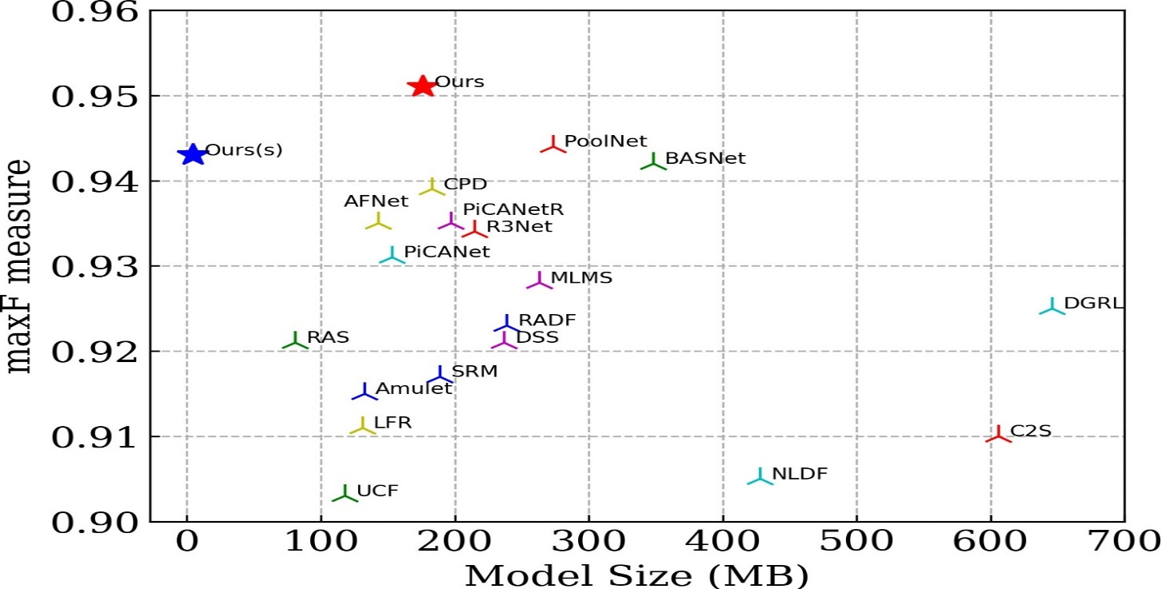

**Fig.1** Comparison of model size and performance

U2 -Net with other state-of-the-art SOD models. The max measure is computed on data set ECSSD. The red star denotes our U2 -Net (Ours) (176.3 MB) and the blue star denotes our small version U2 -Net† (Ours†). This leads to our first question: can we design a new network for SOD, that allows training from scratch and achieves comparable or better performance than those based on existing pre-trained backbones?

There are a couple of more issues on the organization structures for SOD. In the first place, they are regularly excessively confounded [58]. It is incompletely because of the extra component conglomeration modules that are added to the current spines to extricate staggered saliency highlights from these spines. Besides, the current spines typically accomplish further engineering by forfeiting high goal of highlight maps [58]. To run these profound models with moderate memory and computational expense, the component maps are down scaled to bring down goal at beginning phases.

For example, at the early layers of both ResNet and DenseNet [15], a convolution with step of two followed by a maximum pooling with step of two are used to diminish the size of the component guides to one fourth of information guide of tour principle commitment is a novel and basic organization engineering, called U 2 - Net, that tends to the two inquiries above. In the first place, U2 - Net is a two-level settled U-structure that is intended for SOD without utilizing any pre-prepared spines from picture grouping.

It very well may be prepared without any preparation to accomplish cutthroat execution. Second, the novel engineering permits the organization to go further, achieve high goal, without fundamentally expanding the memory and calculation cost. This is accomplished by a settled U-structure: on the base level, we plan a novel ReSidual U-block (RSU), which can remove intra-stage multi-scale highlights without corrupting the element map goal; on the high level, there is a U-Net like construction, where each stage is filled by a RSU block. The two-level setup brings about a settled U-structure.

Our U2 - Net (176.3 MB) accomplishes serious execution against the condition of-the art (SOTA) techniques on six public datasets, and runs at constant (30 FPS, with input size of 320×320×3) on a 1080Ti GPU. To work with the use of our plan in calculation and memory obliged conditions, we give a little form of our U2 - Net, called U 2 - Net† (4.7 MB). The U2 - Net† accomplishes serious outcomes against the majority of the SOTA models at 40 FPS.

**2.FEASIBILITY STUDY**

With the advancement of internet technology and the change in the mode of communication, it is found that much first-hand news have been discussed in Internet forums well before they are reported in traditional mass media. Also, this communication channel provides an effective channel for illegal activities such as dissemination of copyrighted movies, threatening messages and online gambling etc. Our proposed System will analyze online plain text sources from selected discussion forums and will classify the text into different groups and system will decide which post is legal and illegal.

The feasibility of the project is analyzed in this phase and business proposal is put forth with a very general plan for the project and some cost estimates. During system analysis the feasibility study of the proposed system is to be carried out. This is to ensure that the proposed system is not a burden to the company. For feasibility analysis, some understanding of the major requirements for the system is essential.

Three key considerations involved in the feasibility analysis are

* + - * TECHNICAL FEASIBILITY
      * ECONOMICAL FEASIBILITY
      * SOCIAL FEASIBILITY

#### Technical Feasibility

This study is carried out to check the technical feasibility, that is, the technical requirements of the system. Any system developed must not have a high demand on the available technical resources. This will lead to high demands on the available technical resources. This will lead to high demands being placed on the client. The developed system must have a modest requirement, as only minimal or null changes are required for implementing this system.

This system is more reliable, maintainable, affordable and producible. These are the parameters which are considered during design and development of this project. During design and development phase of this project there was appropriate and timely application of engineering and management efforts to meet the previously mentioned parameters.

#### Economical Feasibility

This study is carried out to check the economic impact that the system will have on the organization. The amount of fund that the company can pour into the research and development of the system is limited. The expenditures must be justified. Thus the developed system as well within the budget and this was achieved because most of the technologies used are freely available. Only the customized products had to be purchased.

This system can be used by many websites such as social networking sites and other websites in which discussion forums are available. This system will reduce illegal activities held on internet. This system will provide economic benefits for many websites. It includes quantification and identification of all the benefits expected.

#### 2.3 Social Feasibility

The aspect of study is to check the level of acceptance of the system by the user. This includes the process of training the user to use the system efficiently. The user must not feel threatened by the system, instead must accept it as a necessity. The level of acceptance by the users solely depends on the methods that are employed to educate the user about the system and to make him familiar with it. His level of confidence must be raised so that he is also able to make some constructive criticism, which is welcomed, as he is the final user of the system.

**3. SYSTEM ANALYSIS**

**3.1 System Study**

System Analysis is first stage according to System Development Life Cycle model. This System Analysis is a process that starts with the analyst.

Analysis is a detailed study of the various operations performed by a system and their relationships within and outside of the system. One aspect of analysis is defining the boundaries of the system and determining whether or not a candidate system should consider other related systems. During analysis, data are collected on the available files, decision points, and transactions handled by the present system.

To build the drag and drop feature for adding files to a website or attaching them to our emails just by dragging those from their location to the website application has become second nature to us. It is a feature that saves minutes of tedious browsing through the pop-up window, which does not let us switch to a different screen until the file is selected, or the user decides to quit. But imagine an extension of this feature wherein you could drag and drop real-world objects into your digital world, wouldn’t that ease your life? Augmented reality answers this, now enabling us to copy-paste real-world items into your digital screens just by few clicks.

* 1. **Advantages**
* In the fields of plan, it can help decrease the latency for clients to decipher hand-drawn or antiquated outline directly into your workspace in practically no time.
* For the scholarly community related assignments, AR reorder can help make a more successful show, computerize carrying printed writings to your advanced workspace
* Searching experience particularly can be made more intuitive, more liquid, expanding the client experience on the off chance that we can duplicate genuine content, photographs, sounds, and glue them straightforwardly to look through bars.
* It can make client commitment: Games or applications can be made more client connecting with, simply envision utilizing Augmented Reality for advanced world Treasure-Hunt games wherein you need to duplicate glue genuine items.
  1. **AUGMENTED REALITY**

When you say augmented reality, people often think of movies like “Iron Man.” But augmented reality (AR) has moved beyond Hollywood, headsets, and gaming and into use cases such as inspection and repair. As interest in AR grows, IT leaders will need to discuss what AR can and can’t do in terms that colleagues, customers, and other audiences will understand.

[IDC](http://www.idc.com/tracker/showproductinfo.jsp?prod_id=1381) predicts that worldwide spending on augmented reality (AR) and virtual reality (VR) will reach $160 billion in 2023, up significantly from their $16.8 billion forecast for 2019. “Augmented reality is gaining share in the commercial market due to its ability to facilitate tasks, provide access to resources, and solve complex problems,” says [Marcus Torchia](https://www.idc.com/getdoc.jsp?containerId=PRF004544), IDC’s research director for [Customer Insights & Analysis](https://www.idc.com/promo/customerinsights).

Industries like manufacturing, utilities, telecommunications, retail, healthcare, and logistics are increasingly adopting AR for a variety of uses, including assembly, maintenance and repair, education and training, retail showcasing, and diagnostics.

**What is augmented reality? 5 ways to explain**

At its most basic level, AR capabilities layer digital information in some form or another atop the analog world in which we live. Here are five simple definitions that may prove useful when engaging in conversations around the potential business value of AR:

* “AR is a technology that enhances or augments your experience of the world around you.” ­– [Tom Emrich](http://www.tomemrich.com/), AR/VR/wearable technology expert and managing director of [AWE](https://www.augmentedworldexpo.com/) (Augmented World Expo)
* “Augmented reality (AR) is the real-time use of information in the form of text, graphics, audio, and other virtual enhancements integrated with real-world objects.” – [Gartner’s IT Glossary](https://www.gartner.com/it-glossary/augmented-reality-ar/)
* “Augmented reality is the rendering of digital images or data onto real-world objects.” – [Bryan Ma](https://www.idc.com/getdoc.jsp?containerId=PRF000243), vice president of client devices research, [IDC](https://www.idc.com/)“ Augmented reality (AR) is superimposed digital information overlaid on a user’s view of a physical environment.” – Leon Laroue, technical product manager of augmented reality solutions, [Epson](https://epson.com/)
* “Augmented reality refers to any technology that ‘augments’ the user’s visual (and in some case auditory) perception of their environment.”
* Typically, digital information is superimposed over a natural existing environment. Information is tailored to the user’s physical position as well as the context of the task, thereby helping the user to solve the problem and complete the task. [The Augmented Reality for Enterprise Alliance](https://thearea.org/why-ar-for-enterprise/area-glossary/).

**AR examples**

Microsoft’s HoloLens headset has been a very visible AR tool, but as experts point out, AR is a much more versatile technology. “Microsoft HoloLens is a poster child for AR, but one has to keep in mind that headsets are not the only way to render it,” says Ma. “If anything, phones and tablets are much more common, even if they are not hands-free like a headset.”

Indeed, that’s one of the most common misperceptions about AR ­­­– and one that can worry users who aren’t keen to wear a headset. Emrich points out, “AR can be experienced today at scale on handheld devices like smartphones and tablets, on magic mirrors and smart displays, as part of projection mapping experiences, as well as wearable devices currently available (and soon to launch) to the market such as smart glasses and hearables.”

Another false assumption is that all AR experiences resemble or are intended to look like something out of “Minority Report” or “Iron Man.” “The fact of the matter is that AR comes in various forms,” says Laroue. “Pokemon Go showed us location-based AR on smartphones. SnapChat gave us video-see-through facial filters (i.e., digital overlays on top of a digital video feed)." Transparent smart glasses enable optical-see-through AR experiences.

Bose, for one, prototyped AR glasses that [layered in sound](https://www.theverge.com/2018/3/12/17106688/bose-ar-audio-augmented-reality-glasses-demo-sxsw-2018) rather than images. In addition, AR experiences vary in terms of their user interfaces, adds Laroue. Some involve physical controllers, while others may integrate voice or gesture controls.

**AR Use Cases**

Emrich likes to explain the value of AR as giving workers “superpowers” via the additional layer of knowledge and insight that AR tools can provide: "AR is already enhancing the workforce in pharmaceuticals, oil and gas, military, aerospace, automotive, manufacturing, and more.”

Industrial use cases are likely to continue to be the most widely adopted for a time, Emrich adds, and were among the first to deliver real benefits.

“In the near term, enterprise AR use cases will be relatively simple and widely applicable,” Laroue says.

One example: The “remote assistance” or the “see-what-I-see” use case.

One example of that is AR for “remote assistance” or the “see-what-I-see” use case. Consider an inspector or repair person in the field: “Enterprise AR adoption within the remote assistance space can be beneficial across a wide range of industries that require inspection, maintenance, and repair out in the field,” Laroue says. “AR remote assistance can be deployed across a wide range of industries, including HVAC and appliance repair, utilities, restaurant, retail, manufacturing, insurance, and many more.”

AR remote assistance can improve training in situations where new hires need help, and enable real-time collaboration between field personnel and remote experts - with the ultimate goal of increased customer satisfaction.

**3.3.4 AR Growth Prospects**

When will AR become more ubiquitous in the enterprise? Some factors to watch, according to Laroue: more of the physical world getting digitally mapped (using GPS, computer vision, and motion sensing); glasses becoming light, immersive, and cheap (less than $1,000); and 3D content creation and authoring going mainstream.

For now, business leaders need to consider what their actual needs are and what problems they’re looking to solve with AR. “It’s very easy to chase flashy AR or mixed-reality features and lose sight of the true goal of improving efficiency or reducing costs,” Laroue notes.

As with many emerging technologies, you can’t lose sight of the business goal. Some problems may be better solved with a smartphone/tablet solution than a hands-free option like smart glasses. “This is all will factor into finding the right AR solution at the right price,” Laroue says.

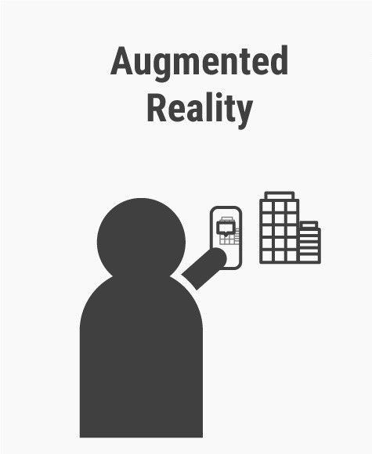

**Fig.2** Augmented Reality

**3.4 METHODOLOGY**

A drag-empowered segment executes the Drag Component interface. It makes a case of Drag Gesture Adapter and a case of Drag Source Adapter. The Drag Source Adapter carries out the Drag Source Listener interface and keeps a reference to a Drag Component object. At the point when a drag is started, the Drag Source Adapter inquiries the Drag Component for the worthy drag activity and a fitting Transferable object(reusable part). On the off chance that this is a move activity, the Drag Source Adapter will advise the Drag Component to move the segment.

The move activity really adds the information to the objective, at that point eliminates the information from the source toward the finish of the D&D activity. These are normally cursor changes. The Drag Component utilizes a Drag Gesture Adapter object, which carries out the Drag Gesture Listener interface, to start the part drag activity. With segments like a JTree, it is conceivable that not everything hubs can be hauled. The Drag Gesture Adapter checks the drag with the Drag Component's is Start Drag Ok() technique, and it enlists the Drag Component's Drag Source Adapter.

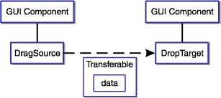

**Fig.3** Drag and Drop

A drop-empowered segment executes the Drop Component interface. The execution is appeared in Below figure (2). Most projects can profit by the capacity to move data, either between segments, between Java applications, or among Java and local applications Drag and drop (DnD) support. The accompanying graph shows the Java bit of a drag activity in our interface. A drag-enabled component implements the Drag Component interface. It creates an instance of DragGestureAdapter and an instance of DragSourceAdapter.

The DragSourceAdapter implements the DragSourceListener interface and maintains a reference to a DragComponent object. When a drag is initiated, the DragSourceAdapter queries the DragComponent for the acceptable drag operation and an appropriate Transferable object (reusable component). If this is a move operation, the DragSourceAdapter will tell the DragComponent to move the component. The move operation actually adds the data to the destination, then removes the data from the source at the end of the D&D operation. These are usually cursor changes.

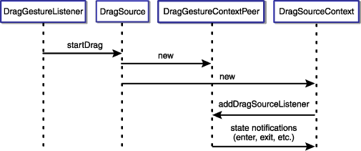

**Fig.4** Drop Component Interface

**Fig.4** Drop Component Interface

**3.4.1 SIFT ALGORITHM**

SIFT helps locate the local features in an image. commonly known as the ‘keypoints‘ of the image. These keypoints are scale and revolution invariant that can be utilized for different PC vision applications, similar to picture coordinating, object recognition, scene location, and so on We can likewise utilize the keypoints produced utilizing SIFT as highlights for the picture during model training. The significant benefit of SIFT highlights, over edge highlights or hoard highlights, is that they are not influenced by the size or direction of the picture**.**

Scale-space peak selection: Potential location for finding features.

Keypoint Localization: Accurately locating the feature Keypoint

Orientation Assignment: Assigning orientation to key points

Keypoint descriptor: Describing the keypoints as a high dimensional vector.

Keypoint Matching.

3.4.1.1 Scale-space peak selection:

Certifiable items are significant just at a specific scale. You may see a sugar shape completely on a table. Yet, on the off chance that taking a gander at the whole smooth way, it just doesn't exist. This multi-scale nature of items is very basic in nature. What's more, a scale space endeavours to repeat this idea on advanced pictures.

The scale space of a picture is a capacity L(x,y,σ) that is created from the convolution of a Gaussian kernel(Blurring) at various scales with the info picture. Scale-space is isolated into octaves and the quantity of octaves and scale relies upon the size of the first picture. So we create a few octaves of the first picture. Every octave's picture size is a large portion of the past one.

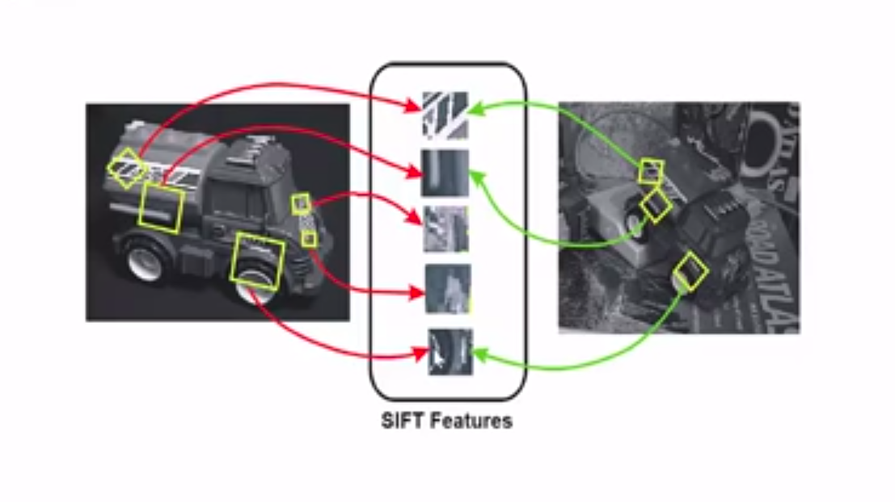

**Fig.5** SIFT Features

**Blurring:**

Inside an octave, pictures are continuously obscured utilizing the Gaussian Blur administrator. Numerically, "obscuring" is alluded to as the convolution of the Gaussian administrator and the picture. Gaussian haze has a specific articulation or "administrator" that is applied to every pixel. What results is the obscured picture.

*L(x,y, $σ$)=G((x,y, $σ$)*I(x,y)-----------------------------------(1)*

Is the Gaussian Blur administrator and I is a picture. While x,y are the area directions and σ is the "scale" boundary. Consider it the measure of obscure. More prominent the worth, more noteworthy the haze.

*G(x,y, $σ$)= $\frac{1}{2πσ^{2}}e^{-(x^{2}+y^{2})/2σ^{2}}$-------------------------------(2)*

**DOG (Difference of Gaussian kernel):**

Presently we utilize those obscured pictures to produce another arrangement of pictures, the Difference of Gaussians (DoG). These DoG pictures are extraordinary for discovering fascinating keypoints in the picture. The distinction of Gaussian is gotten as the distinction of Gaussian obscuring of a picture with two extraordinary σ, let it be σ and kσ. This cycle is accomplished for various octaves of the picture in the Gaussian Pyramid. It is addressed in beneath picture:

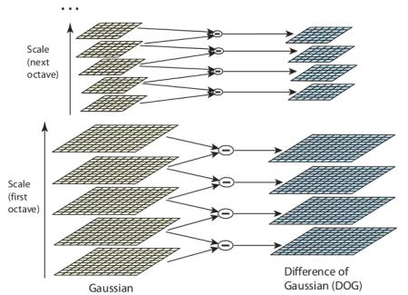

**Fig.6** DOG

**3.4.1.2 Finding keypoints:**

Up till now, we have created a scale space and utilized the scale space to ascertain the Difference of Gaussians. Those are then used to figure Laplacian of Gaussian approximations that are scale invariant

One pixel in a picture is contrasted and its 8 neighbors just as 9 pixels in the following scale and 9 pixels in past scales. Thusly, a sum of 26 checks are made. On the off chance that it is a nearby extrema, it is a potential keypoint. It fundamentally implies that keypoint is best addressed around there.

So what do we do about the remaining keypoints? Well, we perform a check to identify the poorly located keypoints. These are the keypoints that are close to the edge and have a high edge response but may not be robust to a small amount of noise. A second-order Hessian matrix is used to identify such keypoints. You can go through the math behind this here.

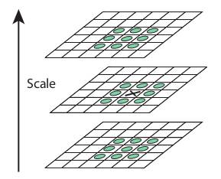

Fig.7 Finding Keypoints

3.4.1.3 Keypoint Localization:

Keypoints created in the past advance produce a great deal of keypoints. Some of them lie along an edge, or they need more difference. In the two cases, they are not as helpful as highlights. So we dispose of them. The methodology is like the one utilized in the Harris Corner Detector for removing edge highlights. For low differentiation highlights, we just check their powers.

They utilized Taylor arrangement development of scale space to get a more exact area of extrema, and if the power at this extreme is not exactly an edge esteem (0.03 according to the paper), it is dismissed. Canine has a higher reaction for edges, so edges likewise should be taken out. They utilized a 2x2 Hessian lattice (H) to register the important curve.

Up till now, we have made a scale space and used the scale space to determine the Difference of Gaussians. Those are then used to figure Laplacian of Gaussian approximations that are scale invariant.We currently have potential keypoints that address the pictures and are scale-invariant. We will apply the last check over the chose keypoints to guarantee that these are the most exact keypoints to address the picture.

So what do we do about the excess keypoints? All things considered, we play out a check to distinguish the inadequately found keypoints. These are the keypoints that are near the edge and have a high edge reaction however may not be powerful to a limited quantity of clamor. A second-request Hessian framework is utilized to distinguish such keypoints. You can go through the math behind this here.

Reject Flats

$$\left|D\left(X\right)\right| <0.03$$

Reject Edges

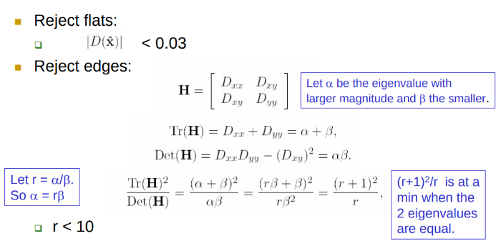 $Let r=α/β$

$So α=rβ$

*Tr(****H****) = Dxy + Dxy =*

Let $α$ be the eigen value with larger magnitude and $β$ the smaller

*Det(****H****) = DxyDyy – (Dxy)2=*

*= = =*

(r+1)2 is at a min when 2 eigen values

are equal

*r < 10*

**3.4.1.4 Orientation Assignment:**

Presently we have real keypoints. They've been tried to be steady. We definitely know the scale at which the keypoint was identified (it's equivalent to the size of the obscured picture). So we have scale invariance. The following thing is to dole out a direction to each keypoint to make it turn invariance. An area is taken around the keypoint area relying upon the scale, and the inclination greatness and heading is determined around there.

A direction histogram with 36 canisters covering 360 degrees is made. Suppose the inclination heading at one point (in the "direction assortment locale") is 18.759 degrees, at that point it will go into the 10–19-degree canister. Also, the "sum" that is added to the receptacle is corresponding to the size of the slope by then. Whenever you've done this for all pixels around the keypoint, the histogram will have a top sooner or later.

Let's say the gradient direction at a certain point (in the “orientation collection region”) is 18.759 degrees, then it will go into the 10–19-degree bin. And the “amount” that is added to the bin is proportional to the magnitude of the gradient at that point. Once you’ve done this for all pixels around the keypoint, the histogram will have a peak at some point.  .The highest peak in the histogram is taken and any peak above 80% of it is also considered to calculate the orientation. It creates keypoints with same location and scale, but different directions. It contributes to the stability of matching.

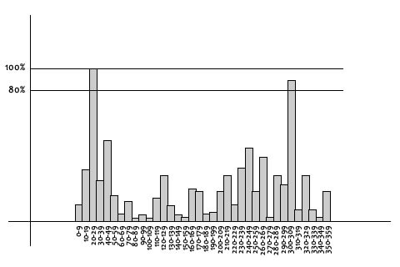

**Fig.8** graph orientation

**3.4.1.5 Keypoint Matching:**

Keypoints between two pictures are coordinated by distinguishing their closest neighbors. Be that as it may, now and again, the second nearest match might be close to the first. It might occur because of commotion or some different reasons. Around there, the proportion of nearest distance to second-nearest remove is taken. In the event that it is more noteworthy than 0.8, they are dismissed. It wipes out around 90% of bogus matches while disposes of just 5% right matches, according to the paper.

At this point, each keypoint has a location, scale, orientation. Next is to compute a descriptor for the local image region about each keypoint that is highly distinctive and invariant as possible to variations such as changes in viewpoint and illumination.

Rotation dependence The feature vector uses gradient orientations. Clearly, if you rotate the image, everything changes. All gradient orientations also change. To achieve rotation independence, the keypoint’s rotation is subtracted from each orientation. Thus each gradient orientation is relative to the keypoint’s orientation. So far, we have stable keypoints that are scale-invariant and rotation invariant. In this section, we will use the neighbouring pixels, their orientations, and magnitude, to generate a unique fingerprint for this keypoint called a ‘descriptor’. Additionally, since we use the surrounding pixels, the descriptors will be partially invariant to illumination or brightness of the images. We will first take a 16×16 neighborhood around the keypoint. This 16×16 block is further divided into 4×4 sub-blocks and for each of these sub-blocks, we generate the histogram using magnitude and orientation.

**3.5** **Input Design**

The input design is the link between the information system and the user. It comprises the developing specification and procedures for data preparation and those steps are necessary to put transaction data in to a usable form for processing can be achieved by inspecting the computer to read data from a written or printed document or it can occur by having people keying the data directly into the system. The design of input focuses on controlling the amount of input required, controlling the errors, avoiding delay, avoiding extra steps and keeping the process simple.

The input is designed in such a way so that it provides security and ease of use with retaining the privacy. Input Design considered the following things:

➢ What data should be given as input?

➢ How the data should be arranged or coded?

➢ The dialog to guide the operating personnel in providing input.

➢ Methods for preparing input validations and steps to follow when error occur.

* 1. **Output Design**

A quality output is one, which meets the requirements of the end user and presents the information clearly. In any system results of processing are communicated to the users and to other system through outputs. In output design it is determined how the information is to be displaced for immediate need and also the hard copy output. It is the most important and direct source information to the user. Efficient and intelligent output design improves the system’s relationship to help user decision-making.

* Designing computer output should proceed in an organized, well thought out manner; the right output must be developed while ensuring that each output element is designed so that people will find the system can use easily and effectively. When analysis design computer output, they should Identify the specific output that is needed to meet the requirements.
* Select methods for presenting information.
* Create document, report, or other formats that contain information produced by the system.

**3.7 System Requirements**

**3.7.1 Software Requirements**

* Operating System :Windows Family
* Coding Language : Python 3.6 & 3.7, React js
* Editor : Adobe Photo Shop or clip Editor
* App : EXPO App (react application)
* Sever : Node js Open Source Server
* Plugin Software : AR Clip Drop Tool

**3.7.2 Hardware Requirements**

* CPU : 64-bit operating system, x64-based processor
* HDD : TB
* RAM : GB
* Mobile : Android, Ios

**4.SOFTWARE ENVIRONMENT**

**4.1 Introduction to Python**

Python is an interpreted, high-level, general-purpose programming language. Created by Guido van Rossum and first released in 1991, Python's design philosophy emphasizes code readability with its notable use of significant whitespace. Its language constructs and object-oriented approach aim to help programmers write clear, logical code for small and large-scale projects. Python is dynamically typed and garbage-collected. It supports multiple programming paradigms, including structured (particularly, procedural), object-oriented, and functional programming. Python is often described as a "batteries included" language due to its comprehensive standard library. Python was conceived in the late 1980s as a successor to the ABC language. Python 2.0, released in 2000, introduced features like list comprehensions and a garbage collection system capable of collecting reference cycles.

Python 3.0, released in 2008, was a major revision of the language that is not completely backward-compatible, and much Python 2 code does not run unmodified on Python 3. The Python 2 language, i.e., Python 2.7.x, was officially discontinued on 1 January 2020 (first planned for 2015) after which security patches and other improvements will not be released for it.[32][33] With Python 2's end-of-life, only Python 3.5.x and later are supported. Python interpreters are available for many operating systems. A global community of programmers develops and maintains CPython, an open-source implementation. A non-profit organization, the Python Software Foundation, manages and directs resources for Python and CPython development.

**SYNTAX AND SEMANTICS**

Python is meant to be an easily readable language. Its formatting is visually uncluttered, and it often uses English keywords where other languages use punctuation.

Unlike many other languages, it does not use curly brackets to delimit blocks, and semicolons after statements are optional. It has fewer syntactic exceptions and special cases than C or Pascal.

**INDENTION**

Main article: Python syntax and semantics § Indentation

Python uses whitespace indentation, rather than curly brackets or keywords, to delimit blocks. An increase in indentation comes after certain statements; a decrease in indentation signifies the end of the current block. Thus, the program's visual structure accurately represents the program's semantic structure. This feature is sometimes termed the off-side rule, which some other languages share, but in most languages, indentation doesn't have any semantic meaning.

**STATEMENTS AND CONTROL FLOW**

Python's statements include (among others):

The assignment statement (token '=', the equals sign). This operates differently than in traditional imperative programming languages, and this fundamental mechanism (including the nature of Python's version of variables) illuminates many other features of the language. Assignment in C, e.g., x = 2, translates to "typed variable name x receives a copy of numeric value 2". The (right-hand) value is copied into an allocated storage location for which the (left-hand) variable name is the symbolic address. The memory allocated to the variable is large enough (potentially quite large) for the declared type. In the simplest case of Python assignment, using the same example, x = 2, translates to "(generic) name x receives a reference to a separate, dynamically allocated object of numeric (int) type of value 2." This is termed binding the name to the object.

Since the name's storage location doesn't contain the indicated value, it is improper to call it a variable. Names may be subsequently rebound at any time to objects of greatly varying types, including strings, procedures, complex objects with data and methods, etc. Successive assignments of a common value to multiple names, e.g., x = 2; y = 2; z = 2 result in allocating storage to (at most) three names and one numeric object, to which all three names are bound.

Since a name is a generic reference holder it is unreasonable to associate a fixed data type with it. However, at a given time a name will be bound to some object, which will have a type; thus there is dynamic typing.

* The if statement, which conditionally executes a block of code, along with else and elif (a contraction of else-if).
* The for statement, which iterates over an iterable object, capturing each element to a local variable for use by the attached block.
* The while statement, which executes a block of code as long as its condition is true.
* The try statement, which allows exceptions raised in its attached code block to be caught and handled by except clauses; it also ensures that clean-up code in a finally block will always be run regardless of how the block exits.
* The raise statement, used to raise a specified exception or re-raise a caught exception.
* The class statement, which executes a block of code and attaches its local namespace to a class, for use in object-oriented programming.
* The def statement, which defines a function or method.
* The with statement, from Python 2.5 released in September 2006, which encloses a code block within a context manager (for example, acquiring a lock before the block of code is run and releasing the lock afterwards, or opening a file and then closing it), allowing Resource Acquisition Is Initialization (RAII)-like behaviour and replaces a common try/finally idiom.
* The break statement, exits from the loop.
* The continue statement, skips this iteration and continues with the next item.
* The pass statement, which serves as a NOP. It is syntactically needed to create an empty code block.
* The assert statement, used during debugging to check for conditions that ought to apply.
* The yield statement, which returns a value from a generator function. From Python 2.5, yield is also an operator. This form is used to implement coroutines.

The import statement, which is used to import modules whose functions or variables can be used in the current program. There are three ways of using import: import <module name> [as <alias>] or from <module name> import * or from <module name> import <definition 1> [as <alias 1>], <definition 2> [as <alias 2>],

The print statement was changed to the print () function in Python 3.

Python does not support tail call optimization or first-class continuations, and, according to Guido van Rossum, it never will. However, better support for coroutine-like functionality is provided in 2.5, by extending Python's generators. Before 2.5, generators were lazy iterators; information was passed unidirectionally out of the generator. From Python 2.5, it is possible to pass information back into a generator function, and from Python 3.3, the information can be passed through multiple stack levels.

**EXPRESSIONS**

Some Python expressions are similar to languages such as C and Java, while some are not:

Addition, subtraction, and multiplication are the same, but the behaviour of division differs. There are two types of divisions in Python. They are floor division (or integer division) // and floating point/division. Python also added the ** operator for exponentiation.

From Python 3.5, the new @ infix operator was introduced. It is intended to be used by libraries such as NumPy for matrix multiplication.

From Python 3.8, the syntax: =, called the 'walrus operator' was introduced. It assigns values to variables as part of a larger expression.

In Python, == compares by value, versus Java, which compares numeri’s by value and objects by reference. (Value comparisons in Java on objects can be performed with the equals () method.) Python's is operator may be used to compare object identities (comparison by reference). In Python, comparisons may be chained, for example a <= b <= c.

Python uses the words and, or, not for its Boolean operators rather than the symbolic &&, ||, ! used in Java and C.

Python has a type of expression termed a list comprehension. Python 2.4 extended list comprehensions into a more general expression termed a generator expression.

Anonymous functions are implemented using lambda expressions; however, these are limited in that the body can only be one expression.

Conditional expressions in Python are written as x if c else y (different in order of operands from the c? x : y operator common to many other languages).

Python makes a distinction between lists and tuples. Lists are written as [1, 2, 3], are mutable, and cannot be used as the keys of dictionaries (dictionary keys must be immutable in Python). Tuples are written as (1, 2, 3), are immutable and thus can be used as the keys of dictionaries, provided all elements of the tuple are immutable. The + operator can be used to concatenate two tuples, which does not directly modify their contents, but rather produces a new tuple containing the elements of both provided tuples. Thus, given the variable t initially equal to (1, 2, 3), executing t = t + (4, 5) first evaluates t + (4, 5), which yields (1, 2, 3, 4, 5), which is then assigned back to t, thereby effectively "modifying the contents" of t, while conforming to the immutable nature of tuple objects. Parentheses are optional for tuples in unambiguous contexts.

Python features sequence unpacking wherein multiple expressions, each evaluating to anything that can be assigned to (a variable, a writable property, etc.), are associated in the identical manner to that forming tuple literals and, as a whole, are put on the left-hand side of the equal sign in an assignment statement. The statement expects an iterable object on the right-hand side of the equal sign that produces the same number of values as the provided writable expressions when iterated through, and will iterate through it, assigning each of the produced values to the corresponding expression on the left.

Python has a "string format" operator %. These functions analogous to printf format strings in C, e.g. "spam=%s eggs=%d" % ("blah", 2) evaluates to "spam=blah eggs=2".

In Python 3 and 2.6+, this was supplemented by the format () method of the str class, e.g. "spam={0} eggs={1}". format("blah", 2). Python 3.6 added "f-strings": blah = "blah"; eggs = 2; f'spam={blah} eggs={eggs}'.

**Python has various kinds of string literals**

Strings delimited by single or double quote marks. Unlike in Unix shells, Perl and Perl-influenced languages, single quote marks and double quote marks function identically. Both kinds of string use the backslash (\) as an escape character. String interpolation became available in Python 3.6 as "formatted string literals".

Triple-quoted strings, which begin and end with a series of three single or double quote marks. They may span multiple lines and function like here documents in shells, Perl and Ruby.

Raw string varieties, denoted by prefixing the string literal with an r. Escape sequences are not interpreted; hence raw strings are useful where literal backslashes are common, such as regular expressions and Windows-style paths. Compare "@-quoting" in C#.

Python has array index and array slicing expressions on lists, denoted as a[key], a[start: stop] or a[start:stop:step]. Indexes are zero-based, and negative indexes are relative to the end. Slices take elements from the start index up to, but not including, the stop index. The third slice parameter, called step or stride, allows elements to be skipped and reversed. Slice indexes may be omitted, for example a[:] returns a copy of the entire list. Each element of a slice is a shallow copy.

In Python, a distinction between expressions and statements is rigidly enforced, in contrast to languages such as Common Lisp, Scheme, or Ruby. This leads to duplicating some functionality. For example:

List comprehensions vs. for-loops

Conditional expressions vs. if blocks

The eval() vs. exec() built-in functions (in Python 2, exec is a statement); the former is for expressions, the latter is for statements.

Statements cannot be a part of an expression, so list and other comprehensions or lambda expressions, all being expressions, cannot contain statements. A particular case of this is that an assignment statement such as a = 1 cannot form part of the conditional expression of a conditional statement. This has the advantage of avoiding a classic C error of mistaking an assignment operator = for an equality operator == in conditions: if (c = 1) { ... } is syntactically valid (but probably unintended) C code but if c = 1: ... causes a syntax error in Python.

**METHODS**

Methods on objects are functions attached to the object's class; the syntax instance. method(argument) is, for normal methods and functions, syntactic sugar for Class. method(instance, argument). Python methods have an explicit self parameter to access instance data, in contrast to the implicit self (or this) in some other object-oriented programming languages (e.g., C++, Java, Objective-C, or Ruby).

**APPLICATIONS OF PYTHON**

As mentioned before, Python is one of the most widely used language over the web. I'm going to list few of them here:

**Easy-to-learn** − Python has few keywords, simple structure, and a clearly defined syntax. This allows the student to pick up the language quickly.

**Easy-to-read** − Python code is more clearly defined and visible to the eyes.

**Easy-to-maintain** − Python's source code is fairly easy-to-maintain.

**A broad standard library** − Python's bulk of the library is very portable and cross-platform compatible on UNIX, Windows, and Macintosh.

**Interactive Mode** − Python has support for an interactive mode which allows interactive testing and debugging of snippets of code.

**Portable** − Python can run on a wide variety of hardware platforms and has the same interface on all platforms.

**Extendable** − You can add low-level modules to the Python interpreter. These modules enable programmers to add to or customize their tools to be more efficient.

**Databases** − Python provides interfaces to all major commercial databases.

**GUI Programming** − Python supports GUI applications that can be created and ported to many system calls, libraries and windows systems, such as Windows MFC, Macintosh, and the X Window system of Unix.

**Scalable** − Python provides a better structure and support for large programs than shell scripting.

# Python OOPs Concepts

Like other general-purpose programming languages, Python is also an object-oriented language since its beginning. It allows us to develop applications using an Object-Oriented approach. In [Python](https://www.javatpoint.com/python-tutorial), we can easily create and use classes and objects.

An object-oriented paradigm is to design the program using classes and objects. The object is related to real-word entities such as book, house, pencil, etc. The oops concept focuses on writing the reusable code. It is a widespread technique to solve the problem by creating objects.

Major principles of object-oriented programming system are given below.

* Class
* Object
* Method
* Inheritance
* Polymorphism
* Data Abstraction
* Encapsulation

## Class

## The class can be defined as a collection of objects. It is a logical entity that has some specific attributes and methods. For example: if you have an employee class, then it should contain an attribute and method, i.e. an email id, name, age, salary, etc.

## Syntax

**class** ClassName:

        <statement-1>

        .

        .

        <statement-N>

## Object

## The object is an entity that has state and behavior. It may be any real-world object like the mouse, keyboard, chair, table, pen, etc.

## Everything in Python is an object, and almost everything has attributes and methods. All functions have a built-in attribute __doc__, which returns the docstring defined in the function source code.

## When we define a class, it needs to create an object to allocate the memory. Consider the following example.

## Method

## The method is a function that is associated with an object. In Python, a method is not unique to class instances. Any object type can have methods.

## Inheritance

## Inheritance is the most important aspect of object-oriented programming, which simulates the real-world concept of inheritance. It specifies that the child object acquires all the properties and behaviors of the parent object.

## By using inheritance, we can create a class which uses all the properties and behavior of another class. The new class is known as a derived class or child class, and the one whose properties are acquired is known as a base class or parent class.

## it provides the re-usability of the code.

## Polymorphism

## Polymorphism contains two words "poly" and "morphs". Poly means many, and morph means shape. By polymorphism, we understand that one task can be performed in different ways. For example - you have a class animal, and all animals speak. But they speak differently. Here, the "speak" behavior is polymorphic in a sense and depends on the animal. So, the abstract "animal" concept does not actually "speak", but specific animals (like dogs and cats) have a concrete implementation of the action "speak".

## Encapsulation

## Encapsulation is also an essential aspect of object-oriented programming. It is used to restrict access to methods and variables. In encapsulation, code and data are wrapped together within a single unit from being modified by accident.

## Data Abstraction

## Data abstraction and encapsulation both are often used as synonyms. Both are nearly synonyms because data abstraction is achieved through encapsulation.

## Abstraction is used to hide internal details and show only functionalities. Abstracting something means to give names to things so that the name captures the core of what a function or a whole program does.

# Python Class and Objects

# We have already discussed in previous tutorial, a class is a virtual entity and can be seen as a blueprint of an object. The class came into existence when it instantiated. Let's understand it by an example.

# Suppose a class is a prototype of a building. A building contains all the details about the floor, rooms, doors, windows, etc. we can make as many buildings as we want, based on these details. Hence, the building can be seen as a class, and we can create as many objects of this class.

# On the other hand, the object is the instance of a class. The process of creating an object can be called instantiation.

# In this section of the tutorial, we will discuss creating classes and objects in Python. We will also discuss how a class attribute is accessed by using the object.

## Creating classes in Python

## In Python, a class can be created by using the keyword class, followed by the class name. The syntax to create a class is given below.

## ****Syntax****

**class** ClassName:

 #statement_suite

In Python, we must notice that each class is associated with a documentation string which can be accessed by using **<class-name>.__doc__.** A class contains a statement suite including fields, constructor, function, etc. definition.

Consider the following example to create a class **Employee** which contains two fields as Employee id, and name.

The class also contains a function **display(),** which is used to display the information of the **Employee.**

Here, the **self**is used as a reference variable, which refers to the current class object. It is always the first argument in the function definition. However, using **self** is optional in the function call.

**The self-parameter**

The self-parameter refers to the current instance of the class and accesses the class variables. We can use anything instead of self, but it must be the first parameter of any function which belongs to the class.

**Creating an instance of the class**

A class needs to be instantiated if we want to use the class attributes in another class or method. A class can be instantiated by calling the class using the class name.

The syntax to create the instance of the class is given below.

<object-name> = <class-name>(<arguments>)

The following example creates the instance of the class Employee defined in the above example.

**Python Inheritance**

Inheritance is an important aspect of the object-oriented paradigm. Inheritance provides code reusability to the program because we can use an existing class to create a new class instead of creating it from scratch.

In inheritance, the child class acquires the properties and can access all the data members and functions defined in the parent class. A child class can also provide its specific implementation to the functions of the parent class. In this section of the tutorial, we will discuss inheritance in detail.

In python, a derived class can inherit base class by just mentioning the base in the bracket after the derived class name. Consider the following syntax to inherit a base class into the derived class.



### **Syntax**

**class** derived-**class**(base **class**):

  <**class**-suite>

## Python Multi-Level inheritance

## Multi-Level inheritance is possible in python like other object-oriented languages. Multi-level inheritance is archived when a derived class inherits another derived class. There is no limit on the number of levels up to which, the multi-level inheritance is archived in python.



## Python Multiple inheritance

## Python provides us the flexibility to inherit multiple base classes in the child class.

## 

## Method Overriding

## We can provide some specific implementation of the parent class method in our child class. When the parent class method is defined in the child class with some specific implementation, then the concept is called method overriding. We may need to perform method overriding in the scenario where the different definition of a parent class method is needed in the child class.

## Data abstraction in python

## Abstraction is an important aspect of object-oriented programming. In python, we can also perform data hiding by adding the double underscore (___) as a prefix to the attribute which is to be hidden. After this, the attribute will not be visible outside of the class through the object.

# Abstraction in Python

Abstraction is used to hide the internal functionality of the function from the users. The users only interact with the basic implementation of the function, but inner working is hidden. User is familiar with that **"what function does"** but they don't know **"how it does."**

In simple words, we all use the smartphone and very much familiar with its functions such as camera, voice-recorder, call-dialing, etc., but we don't know how these operations are happening in the background. Let's take another example - When we use the TV remote to increase the volume. We don't know how pressing a key increases the volume of the TV. We only know to press the "+" button to increase the volume.

That is exactly the abstraction that works in the [object-oriented concept](https://www.javatpoint.com/python-oops-concepts).

## Why Abstraction is Important?

In Python, an abstraction is used to hide the irrelevant data/class in order to reduce the complexity. It also enhances the application efficiency. Next, we will learn how we can achieve abstraction using the [Python program](https://www.javatpoint.com/python-programs).

**Syntax**

from abc **import** ABC

**class** ClassName(ABC):

We import the ABC class from the **abc** module.

## Abstract Base Classes

An abstract base class is the common application program of the interface for a set of subclasses. It can be used by the third-party, which will provide the implementations such as with plugins. It is also beneficial when we work with the large code-base hard to remember all the classes.

## Working of the Abstract Classes

Unlike the other high-level language, Python doesn't provide the abstract class itself. We need to import the abc module, which provides the base for defining Abstract Base classes (ABC). The ABC works by decorating methods of the base class as abstract. It registers concrete classes as the implementation of the abstract base. We use the @abstractmethod decorator to define an abstract method or if we don't provide the definition to the method, it automatically becomes the abstract method. Let's understand the following example.

**4.2 INSTALLATION OF PYTHON**

Installing and using Python on Windows 10 is very simple. The installation procedure involves just three steps:

* Download the binaries
* Run the Executable installer
* Add Python to PATH environmental variables

To install Python, you need to download the official Python executable installer. Next, you need to run this installer and complete the installation steps. Finally, you can configure the PATH variable to use python from the command line.

**Step 1**: Download the Python Installer binaries

* Open the official Python website in your web browser. Navigate to the Downloads tab for Windows.
* Choose the latest Python 3 release. In our example, we choose the latest Python 3.7.3 version. Click on the link to download Windows x86 executable installer if you are using a 32-bit installer.
* In case your Windows installation is a 64-bit system, then download Windows x86-64 executable installer.

**Step 2:** Run the Executable Installer

1. Once the installer is downloaded, run the Python installer.
2. 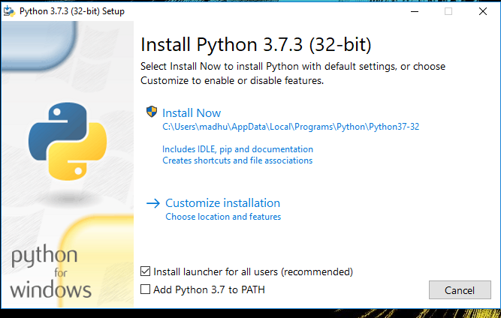Check the Install launcher for all users check box. Further, you may check the Add Python 3.7 to path check box to include the interpreter in the execution path.

**Installation Python 3.7.3**

1. **Select** **Customize installation**.

Choose the optional features by checking the following check boxes:

1. Documentation
2. pip
3. tcl/tk and IDLE (to install tkinter and IDLE)
4. Python test suite (to install the standard library test suite of Python)
5. Install the global launcher for `.py` files. This makes it easier to start Python
6. 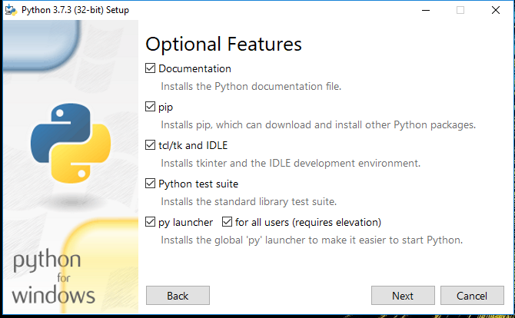Install for all users.

**Fig: Optional Features**

Click Next.

1. This takes you to Advanced Options available while installing Python. Here, select the Install for all users and Add Python to environment variables check boxes.

Optionally, you can select the Associate files with Python, Create shortcuts for installed applications and other advanced options. Make note of the python installation directory displayed in this step. You would need it for the next step.

After selecting the Advanced options, click Install to start installation.

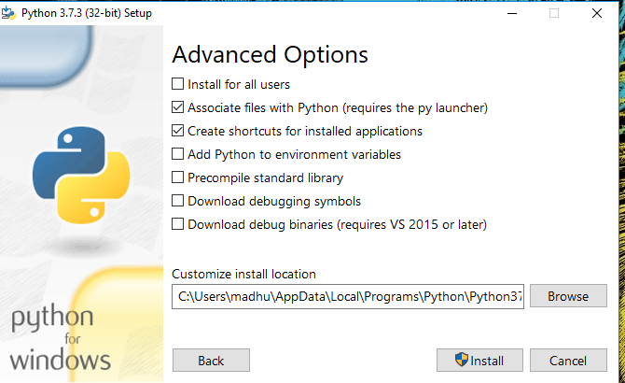

**Fig: Advanced Options**

1. Once the installation is over, you will see a Python Setup Successful window.

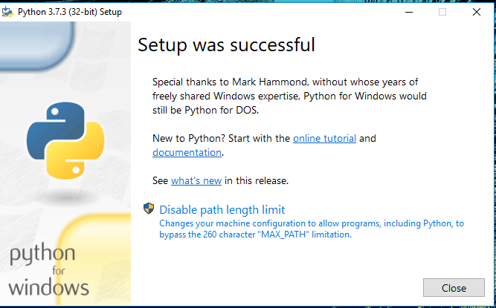

**Fig : Settings Setup**

**Step 3:** Add Python to environmental variables

The last (optional) step in the installation process is to add Python Path to the System Environment variables. This step is done to access Python through the command line. In case you have added Python to environment variables while setting the Advanced options during the installation procedure, you can avoid this step. Else, this step is done manually as follows.

In the Start menu, search for “advanced system settings”. Select “View advanced system settings”. In the “System Properties” window, click on the “Advanced” tab and then click on the “Environment Variables” button.

Locate the Python installation directory on your system. If you followed the steps exactly as above, python will be installed in below locations:

* C:\Program Files (x86)\Python37-32: for 32-bit installation
* C:\Program Files\Python37-32: for 64-bit installation

The folder name may be different from “Python37-32” if you installed a different version. Look for a folder whose name starts with Python.

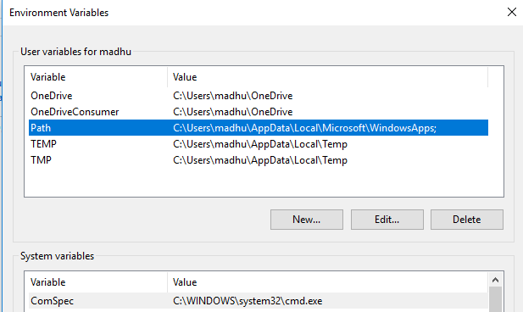Append the following entries to PATH variable as shown below:

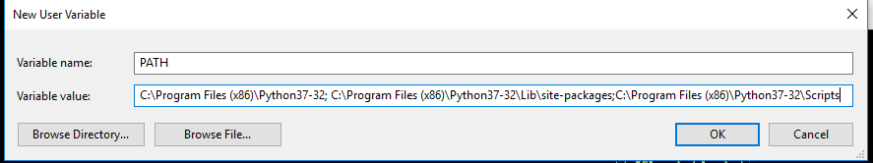

**Environment Settings**

**Step 4:** Verify the Python Installation

You have now successfully installed Python 3.7.3 on Windows 10. You can verify if the Python installation is successful either through the command line or through the IDLE app that gets installed along with the installation. Search for the command prompt and type “python”. You can see that Python 3.7.3 is successfully installed.

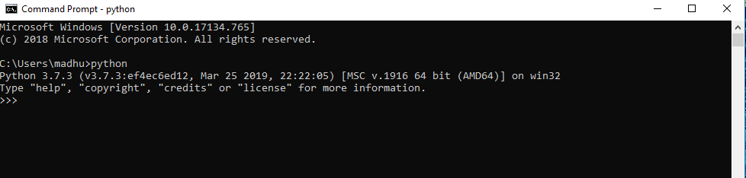

**Fig: Command Prompt**

An alternate way to reach python is to search for “Python” in the start menu and clicking on IDLE (Python 3.7 64-bit). You can start coding in Python using the Integrated Development Environment(IDLE).

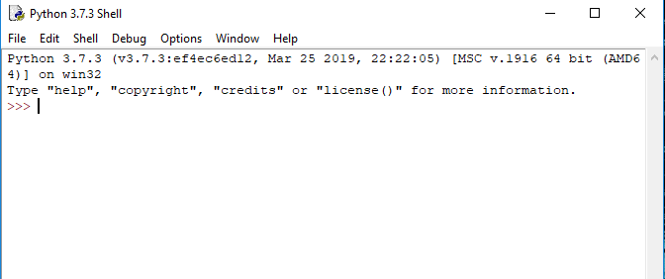

**Python Shell Prompt**

**USES**

Since 2003, Python has consistently ranked in the top ten most popular programming languages in the TIOBE Programming Community Index where, as of February 2020, it is the third most popular language (behind Java, and C). It was selected Programming Language of the Year in 2007, 2010, and 2018.

* An empirical study found that scripting languages, such as Python, are more productive than conventional languages, such as C and Java, for programming problems involving string manipulation and search in a dictionary, and determined that memory consumption was often "better than Java and not much worse than C or C++".
* Large organizations that use Python include Wikipedia, Google, Yahoo!, CERN, NASA, Facebook, Amazon, Instagram, Spotify and some smaller entities like ILM and ITA. The social news networking site Reddit is written entirely in Python.
* Python can serve as a scripting language for web applications, e.g., via mod_wsgi for the Apache web server. With Web Server Gateway Interface, a standard API has evolved to facilitate these applications. Web frameworks like Django, Pylons, Pyramid, TurboGears, web2py, Tornado, Flask, Bottle and Zope support developers in the design and maintenance of complex applications. Pyjs and IronPython can be used to develop the client-side of Ajax-based applications.
* SQLAlchemy can be used as data mapper to a relational database. Twisted is a framework to program communications between computers, and is used (for example) by Dropbox.
* Libraries such as NumPy, SciPy and Matplotlib allow the effective use of Python in scientific computing, with specialized libraries such as Biopython and Astropy providing domain-specific functionality. SageMath is a mathematical software with a notebook interface programmable in Python: its library covers many aspects of mathematics, including algebra, combinatorics, numerical mathematics, number theory, and calculus.
* Python has been successfully embedded in many software products as a scripting language, including in finite element method software such as Abaqus, 3D parametric modeler like FreeCAD, 3D animation packages such as 3ds Max, Blender, Cinema 4D, Lightwave, Houdini, Maya, modo, MotionBuilder, Softimage, the visual effects compositor Nuke, 2D imaging programs like GIMP, Inkscape, Scribus and Paint Shop Pro, and musical notation programs like scorewriter and capella.
* GNU Debugger uses Python as a pretty printer to show complex structures such as C++ containers. Esri promotes Python as the best choice for writing scripts in ArcGIS. It has also been used in several video games, and has been adopted as first of the three available programming languages in Google App Engine, the other two being Java and Go.
* Python is commonly used in artificial intelligence projects with the help of libraries like TensorFlow, Keras, Pytorch and Scikit-learn. As a scripting language with modular architecture, simple syntax and rich text processing tools, Python is often used for natural language processing.
* Many operating systems include Python as a standard component. It ships with most Linux distributions, AmigaOS 4, FreeBSD (as a package), NetBSD, OpenBSD (as a package) and macOS and can be used from the command line (terminal). Many Linux distributions use installers written in Python: Ubuntu uses the Ubiquity installer, while Red Hat Linux and Fedora use the Anaconda installer. Gentoo Linux uses Python in its package management system, Portage.
* Python is used extensively in the information security industry, including in exploit development.
* Most of the Sugar software for the One Laptop per Child XO, now developed at Sugar Labs, is written in Python. The Raspberry Pi single-board computer project has adopted Python as its main user-programming language.
* Due to Python's user-friendly conventions and easy-to-understand language, it is commonly used as an intro language into computing sciences with students. This allows students to easily learn computing theories and concepts and then apply them to other programming languages.
* LibreOffice includes Python, and intends to replace Java with Python. Its Python Scripting Provider is a core feature[169] since Version 4.0 from 7 February 2013.

**4.3 INSTALLATION OF NODE JS APPLICATION**

**Step 1:** Download Node.js Installer for Windows

Go to the site <https://nodejs.org/en/download/> and download the necessary binary files.

In our example, we are going to Download Node.js on Windows with the 32-bit setup files.

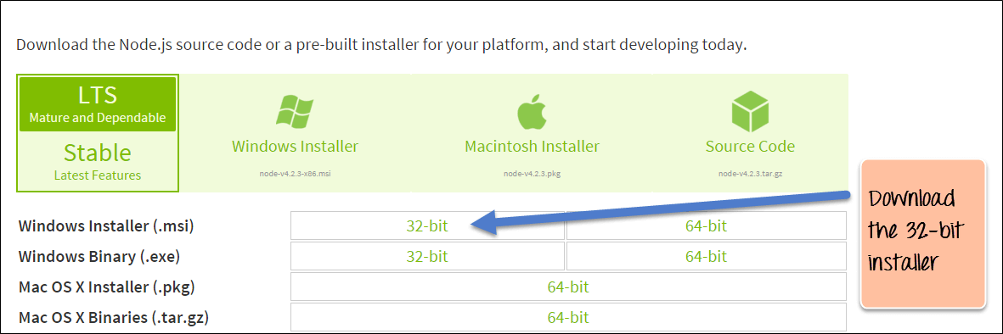

**Node js installer**

**Step 2:** Run the installation

Double click on the downloaded .msi file to start the installation.

Click the Run button on the first screen to begin the installation.

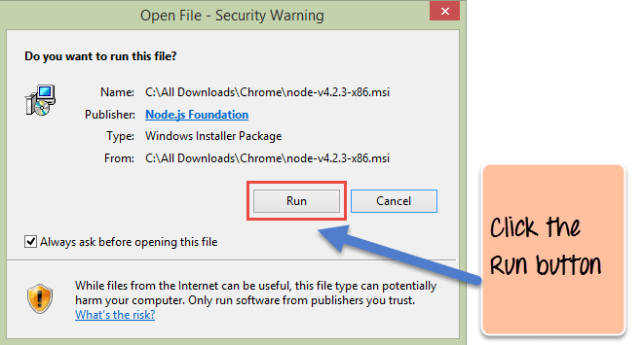

**Security Warning**

**Step 3:** Continue with the installation steps

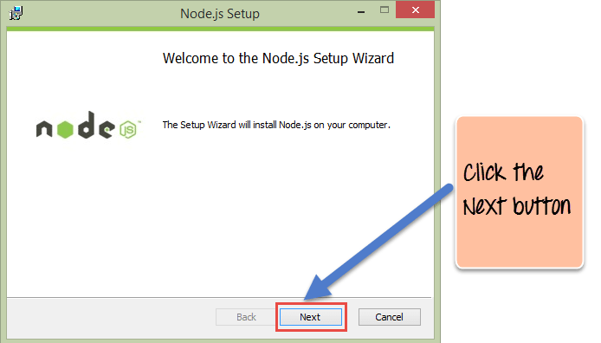In the next screen, click the "Next" button to continue with the installation

**Node.js Setup Wizard**

**Step 4:** Accept the terms and conditions

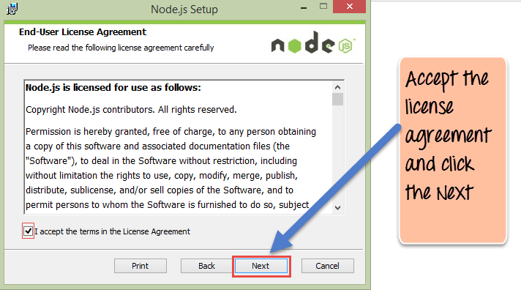In the next screen, Accept the license agreement and click on the Next button.

**Node.js End User License Agreement**

**Step 5:** Set up the path

In the next screen, choose the location where Node.js needs to be installed and then click on the Next button.

1. First, enter the file location for the installation of Node.js. This is where the files for Node.js will be stored after the installation. Click on the Next button to proceed ahead with the installation. 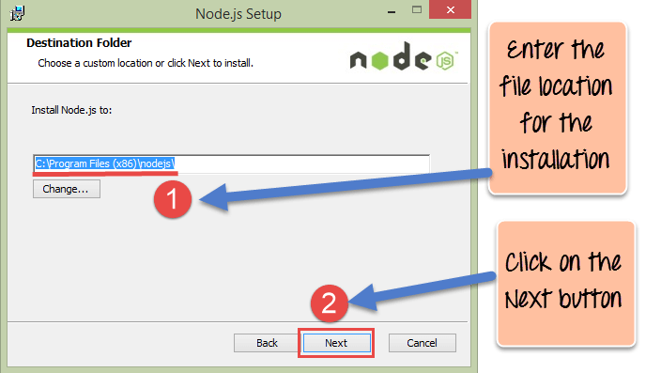

**Destination Folder**

**Step 6:** Select the default components to be installed

Accept the default components and click on the Next button.

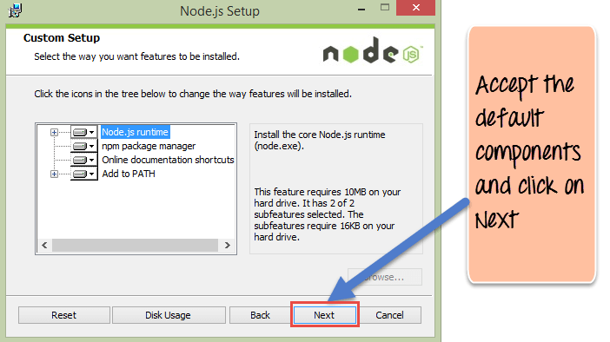

**Custom Setup**

**Step 7:** Start the installation

In the next screen, click the Install button to start installing Node.js on Windows.

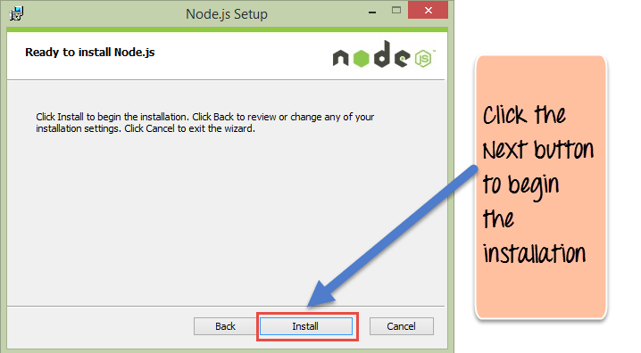

**Ready to install Node.js**

**Step 8:** Complete the installation

Click the Finish button to complete the installation.

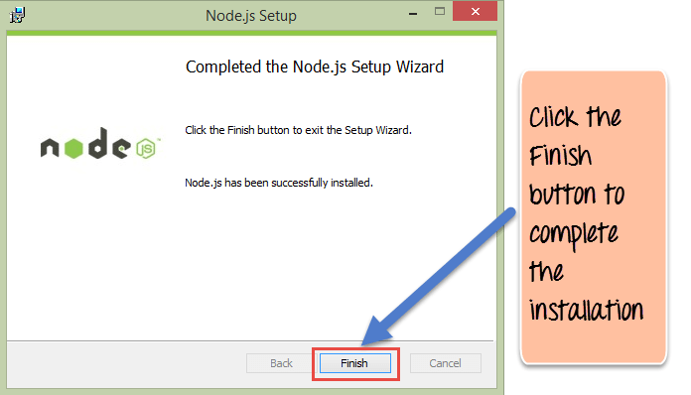

**Completed the Node.js Setup Wizard**

**4.4 INSTALLATION OF PHOTOSHOP**

**Step 1:** Go to the [Creative Cloud website](https://creativecloud.adobe.com/apps/all/desktop/pdp/photoshop), and click **Download**. If prompted, sign in to your Creative Cloud account.

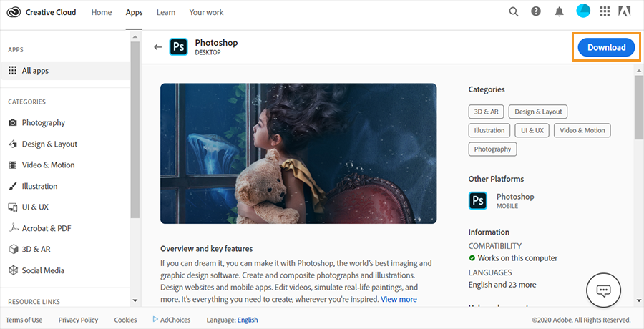

**Creative Cloud**

**Step 2:** Double-click the downloaded file to begin installation.

**Step 3:** Follow the onscreen instructions to complete the installation.

On successful installation, the Creative Cloud desktop app launches at the same time as Photoshop.

**4.5 INSTALLATION OF EXPO APP**

**Step 1: Expo CLI**

Expo CLI is a command line app that is the main interface between a developer and Expo tools. Expo CLI also has a web-based GUI that pops up in your web browser when you start your project — you can use the GUI instead of the command line interface if you're not yet comfortable using a terminal or prefer GUIs, both have similar capabilities.

[**Requirements**](https://docs.expo.io/get-started/installation/#requirements)

* [Node.js LTS release](https://nodejs.org/en/)
* [Git](https://git-scm.com/)
* [Watchman](https://facebook.github.io/watchman/docs/install#buildinstall) for macOS users

[**Recommended Tools**](https://docs.expo.io/get-started/installation/#recommended-tools)

* [VSCode Editor](https://code.visualstudio.com/download)
* [VSCode Expo Extension](https://marketplace.visualstudio.com/items?itemName=byCedric.vscode-expo) for app.json debugging and autocomplete.
* [Yarn](https://classic.yarnpkg.com/en/docs/install)
* Windows users: [PowerShell](https://docs.microsoft.com/en-us/powershell/scripting/install/installing-powershell-core-on-windows), Bash via WSL, or the VSCode terminal.

### [**Installing Expo CLI**](https://docs.expo.io/get-started/installation/#installing-expo-cli)

### # Install the command line

### $ npm install –global expo-cli

Verify that installation was successful by running expo whoami. You are not logged in yet, so you will see “Not logged in”. You can create an account by running expo register if you like, or if you have one already run expo login, but you also don’t need an account to get started.

**Step 2: Expo Go app for iOS and Android**

The fastest way to get up and running is to use the Expo Go app on your iOS or Android device. Expo Go allows you to open up apps that are being served through Expo CLI.

* Android Play Store – Android Lollipop (5) and greater.
* iOS App Store – iOS 11 and greater.

When the Expo Go app is finished installing. Open it up. If you created an account with expo-cli then you can sign in here on the ‘Profile” tab. This will make it easier for you to open projects in the client when you have have them open in development. They will appear automatically in the “Projects” tab of the client app.

**4.6 INSTALLATION OF CLIP DROP APPLICATION**

**Step 1**: Download and **Install MemuPlay** on your PC. Here is the Download link for you – [Memu Play Website](https://www.memuplay.com/). Open the official website and download the software.

**Step 2**: Once the emulator is installed, just open it and **find Google Playstore App** icon on the home screen of Memuplay. Just double tap on that to open.

**Step 3**: Now **search for ClipDrop - AR Copy Paste - Pro App** on Google playstore. Find the official App from Init ML developer and click on the Install button.

**Step 4**: Upon successful installation, you can find ClipDrop - AR Copy Paste - Pro on the home screen of MEmu Play.

**5.SYSTEM DESIGN**

**5.1 System Architecture**

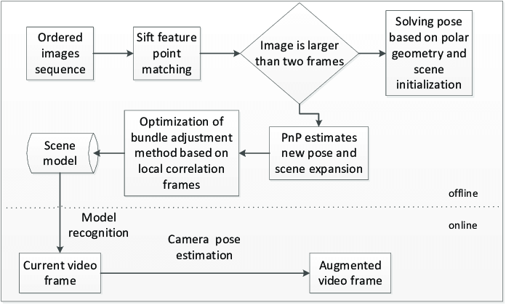

**Fig.9** System Architecture

**5.1.1 Mobile Architecture**

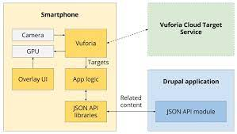

**Fig.10** Mobile Architecture

**5.1.2 PlugIn Server Architecture**

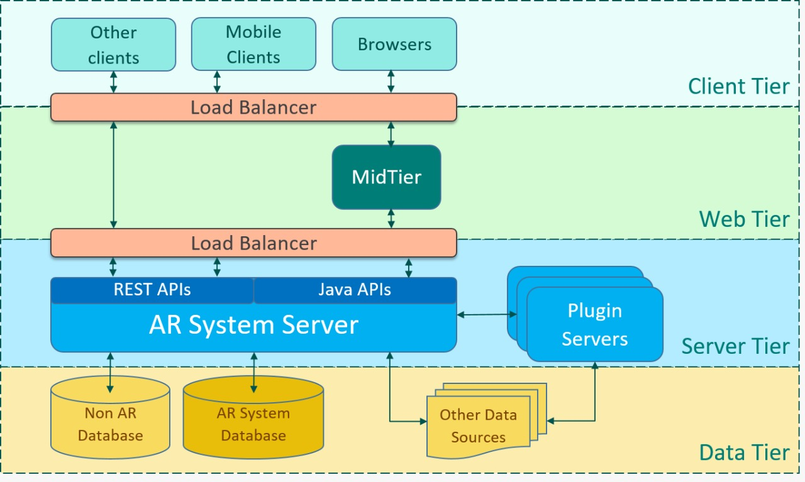

**Fig.11** PlugIn Server Architecture

#### 5.2 Data Flow Diagram:

#### The DFD is also called as bubble chart. It is a simple graphical formalism that can be used to represent a system in terms of input data to the system, various processing carried out on this data, and the output data is generated by this system.

#### The data flow diagram (DFD) is one of the most important modeling tools. It is used to model the system components. These components are the system process, the data used by the process, an external entity that interacts with the system and the information flows in the system.

#### DFD shows how the information moves through the system and how it is modified by a series of transformations. It is a graphical technique that depicts information flow and the transformations that are applied as data moves from input to output.

#### DFD is also known as bubble chart. A DFD may be used to represent a system at any level of abstraction. DFD may be partitioned into levels that represent increasing information flow and functional detail.

#### 

#### Fig.12 Data Flow Diagram

#### UML Diagrams

#### UML stands for Unified Modeling Language. UML is a standardized general-purpose modeling language in the field of object-oriented software engineering. The standard is managed, and was created by, the Object Management Group.

#### The goal is for UML to become a common language for creating models of object oriented computer software. In its current form UML is comprised of two major components: a Meta-model and a notation. In the future, some form of method or process may also be added to; or associated with, UML.

#### The Unified Modeling Language is a standard language for specifying, Visualization, Constructing and documenting the artifacts of software system, as well as for business modeling and other non-software systems.

#### The UML represents a collection of best engineering practices that have proven successful in the modeling of large and complex systems.

#### The UML is a very important part of developing objects oriented software and the software development process. The UML uses mostly graphical notations to express the design of software projects.

#### Goals:

#### The Primary goals in the design of the UML are as follows:

Provide users a ready-to-use, expressive visual modeling Language so that they can develop and exchange meaningful models.

* + 1. Provide extendibility and specialization mechanisms to extend the core concepts.
    2. Be independent of particular programming languages and development process.
    3. Provide a formal basis for understanding the modeling language.
    4. Encourage the growth of OO tools market.
    5. Support higher level development concepts such as collaborations, frameworks, patterns and components.
    6. Integrate best practices.

#### 5.3.1 Use Case Diagram:

A use case diagram in the Unified Modeling Language (UML) is a type of behavioral diagram defined by and created from a Use-case analysis. Its purpose is to present a graphical overview of the functionality provided by a system in terms of actors, their goals (represented as use cases), and any dependencies between those use cases. The main purpose of a use case diagram is to show what system functions are performed for which actor. Roles of the actors in the system can be depicted.

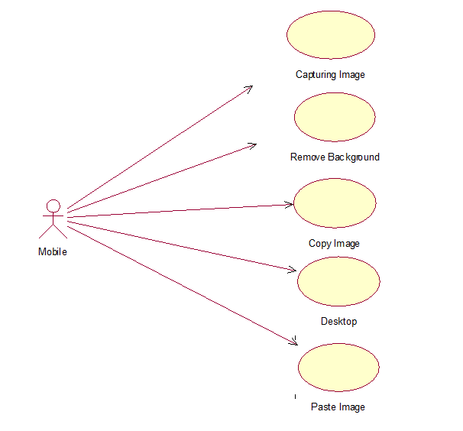

**Fig.13** Use Case Diagram

**5.3.2 Class Diagram:**

In software engineering, a class diagram in the Unified Modeling Language (UML) is a type of static structure diagram that describes the structure of a system by showing the system's classes, their attributes, operations (or methods), and the relationships among the classes. It explains which class contains information.

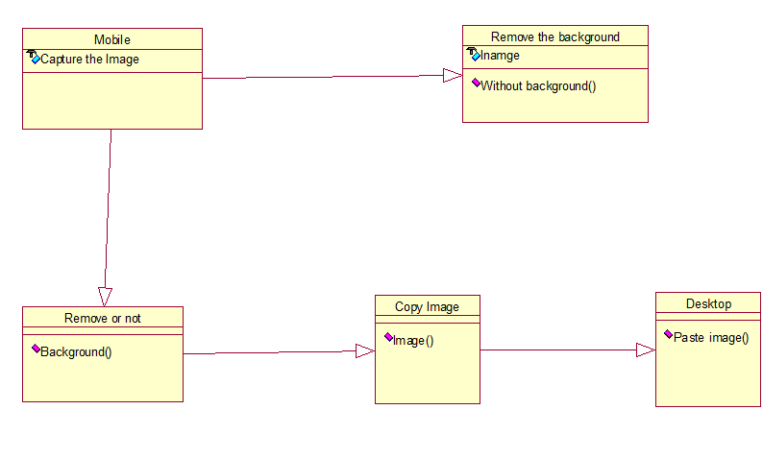

**Fig.14** Class Diagram

**5.3.3 Sequence Diagram**

A sequence diagram in Unified Modeling Language (UML) is a kind of interaction diagram that shows how processes operate with one another and in what order. It is a construct of a Message Sequence Chart. Sequence diagrams are sometimes called event diagrams, event scenarios, and timing diagrams.

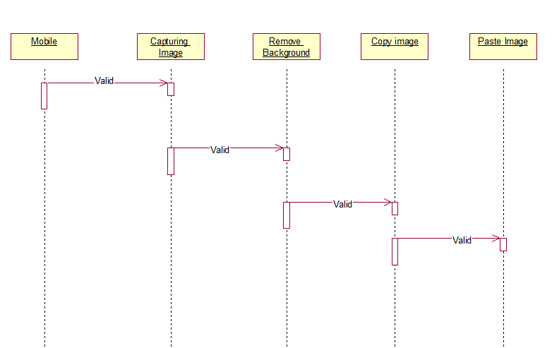

**Fig.15** Sequence Diagram

**5.3.4 Activity Diagram**

Activity diagrams are graphical representations of workflows of stepwise activities and actions with support for choice, iteration and concurrency. In the Unified Modeling Language, activity diagrams can be used to describe the business and operational step-by-step workflows of components in a system. An activity diagram shows the overall flow of control.

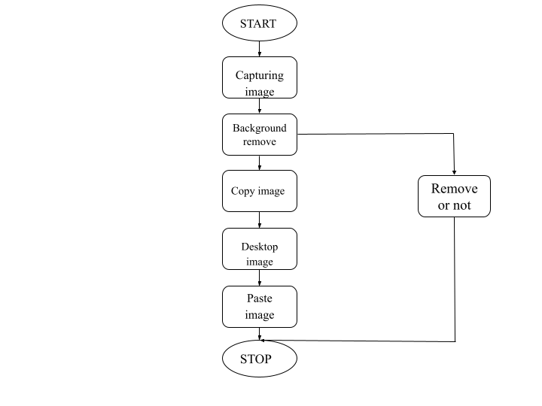

**Fig.16** Activity Diagram

**5.3.5 Deployment Diagram**

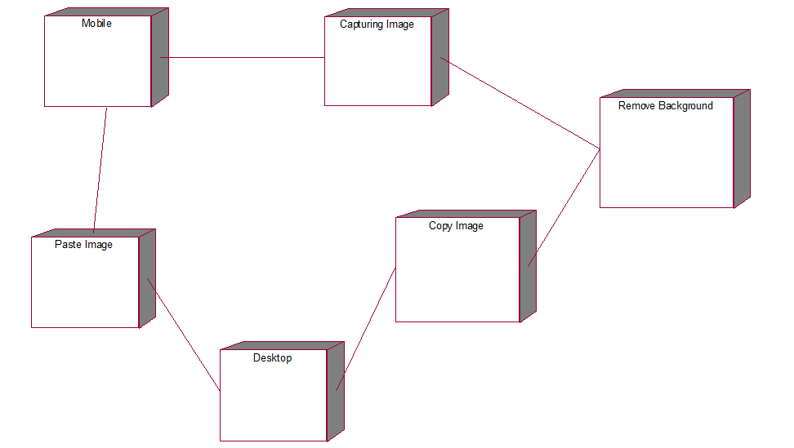Deployment diagrams depict the physical resources in an exceedingly system as well as nodes, components, and connections. A node may be a physical resource that executes code parts.

**Fig.17** Deployment Diagram

**6.IMPLEMENTATION**

**6.1 Modules**

**6.1.1 BASNET**

Deep Convolutional Neural Networks have been adopted for salient object detection and achieved the state-of-the-art performance. Most of the previous works however focus on region accuracy but not on the boundary quality. In this paper, we propose a predict-refine architecture, BASNet, and a new hybrid loss for Boundary-Aware Salient object detection. Specifically, the architecture is composed of a densely supervised Encoder-Decoder network and a residual refinement module, which are respectively in charge of saliency prediction and saliency map refinement.

The hybrid loss guides the network to learn the transformation between the input image and the ground truth in a three-level hierarchy -- pixel-, patch- and map- level -- by fusing Binary Cross Entropy (BCE), Structural SIMilarity (SSIM) and Intersection-over-Union (IoU) losses. Equipped with the hybrid loss, the proposed predict-refine architecture is able to effectively segment the salient object regions and accurately predict the fine structures with clear boundaries. Experimental results on six public datasets show that our method outperforms the state-of-the-art methods both in terms of regional and boundary evaluation measures. Our method runs at over 25 fps on a single GPU.

**6.1.2 OpenCV SIFT Method**

In last couple of chapters, we saw some corner detectors like Harris etc. They are rotation-invariant, which means, even if the image is rotated, we can find the same corners. It is obvious because corners remain corners in rotated image also. But what about scaling? A corner may not be a corner if the image is scaled. For example, check a simple image below. A corner in a small image within a small window is flat when it is zoomed in the same window. So Harris corner is not scale invariant.

**6.1.3 Photoshop**

Photoshop is Adobe's photo editing, image creation and graphic design software. The software provides many image editing features for raster (pixel-based) images as well as vector graphics. It uses a layer-based editing system that enables image creation and altering with multiple overlays that support transparency. Layers can also act as masks or filters, altering underlying colors. Shadows and other effects can be added to the layers.

Photoshop actions include automation features to reduce the need for repetitive tasks. An option known as Photoshop CC (Creative Cloud) allows users to work on content from any computer. Photoshop been the industry standard image manipulation program for so long that its name has become a verb:

It is common parlance to say that an image has been “photoshopped” or even just “shopped." Shopped, in this context, is synonymous with edited, manipulated or faked -- often regardless of the software actually used. Photoshop is used by photographers, graphic designers, video game artists, advertising and meme designers. The software is available for a monthly fee, at this writing between $9.99 and $49.99 depending on the user's requirements and options selected. Photoshop CC is compatible with Intel-based Mac computers and Windows PCs.

**6.1.4 Libraries**

A Python library is a reusable chunk of code that you may want to include in your programs/ projects.Compared to languages like C++ or C, a Python libraries do not pertain to any specific context in Python. Here, a ‘library’ loosely describes a collection of core modules.Essentially, then, a library is a collection of modules. A package is a library that can be installed using a package manager like rubygems or npm.

The Python Standard Library is a collection of exact syntax, token, and semantics of Python. It comes bundled with core Python distribution. We mentioned this when we began with an introduction. It is written in C, and handles functionality like I/O and other core modules. All this functionality together makes Python the language it is.More than 200 core modules sit at the heart of the standard library.

This library ships with Python. But in addition to this library, you can also access a growing collection of several thousand components from the Python Package Index (PyPI). We mentioned it in the previous blog.

**7. SYSTEM TESTING**

The purpose of testing is to discover errors. Testing is the process of trying to discover every conceivable fault or weakness in a work product. It provides a way to check the functionality of components, sub-assemblies, assemblies and/or a finished product It is the process of exercising software with the intent of ensuring that the Software system meets its requirements and user expectations and does not fail in an unacceptable manner. There are various types of test. Each test type addresses a specific testing requirement.

The test process is initiated by developing a comprehensive plan to test the general functionality and special features on a variety of platform combinations. Strict quality control procedures are used.

The process verifies that the application meets the requirements specified in the system requirements document and is bug free. The following are the considerations used to develop the framework from developing the testing methodologies.

**7.1 Unit Testing**

Unit testing involves the design of test cases that validate that the internal program logic is functioning properly, and that program input produces valid outputs. All decision branches and internal code flow should be validated. It is the testing of individual software units of the application .it is done after the completion of an individual unit before integration. This is a structural testing, that relies on knowledge of its construction and is invasive. Unit tests perform basic tests at component level and test a specific business process, application, and/or system configuration. Unit tests ensure that each unique path of a business process performs accurately to the documented specifications and contains clearly defined inputs and expected results.

**7.2 Integration Testing**

Software integration testing is the incremental integration testing of two or more integrated software components on a single platform to produce failures caused by interface defects. The task of the integration test is to check that components or software applications, e.g. components in a software system or – one step up – software applications at the company level – interact without error.

**7.3 Acceptance Testing**

User Acceptance Testing is a critical phase of any project and requires significant participation by the end user. It also ensures that the system meets the functional requirements. Acceptance testing for Data Synchronization:

* The Acknowledgements will be received by the auditor after the data is received by the cloud server
* The auditors audit operation is done only when there is a request from user
* The Status of data information on the cloud is viewed only by the cloud server

|  |  |  |  |  |  |  |  |
| --- | --- | --- | --- | --- | --- | --- | --- |
| **Test Case ID** | **Test Cases** | **Pre-con ditions** | **Input Test Data** | **Steps to be Executed** | **Expected Results** | **Actual Results** | **Pass/ Fail** |
| 1. | Test whether the passivity system is able to Capture the Image | Fix mobile Camera Properly in front of the Image | Surrounding Images or any image and Text. | 1)Fix Mobile properly  2) It will Capturing the Image of Surrounding  area images | Single image capturing | Capturing Normal image | pass |
| 2. | Test by  Removing the background with image | Fix mobile Camera Properly in front of the Image | The click to drag the image for without background | 1)Capture the image  2)Automatically remove the Background | Single image capturing | Capturing without background image | pass |
| 3. | Test when the without background image drag on the area | Fix mobile Camera Properly in front of the Image | Copy the image without background | 1)check copy  image on the mobile mode 2) check the image successfully copy on the mobile | Copying image | Perfectly copying same data | pass |
| 4. | Test by server IP address match on the mobile app and machine | To run server on Photoshop program in python and we can run Expo app gradiles by using Node JS Server | Two Server are matching point is local server IP address | Check the matching on IP address of the server and APP | Matching on keypoint of the images. | Perfectly keypoint match on server IP address | pass |
| 5. | Test when the copying without background images on the desktop in paste same image | Fix mobile Camera Properly in front of the desktop | Paste the image is a without background | 1) check pasted or drop  image on the desktop or machine 2) check the image successfully pasted on the machine | Pasting the without background image on desktop | Perfectly pasted same data on desktop | pass |

**7.4 Test Cases**

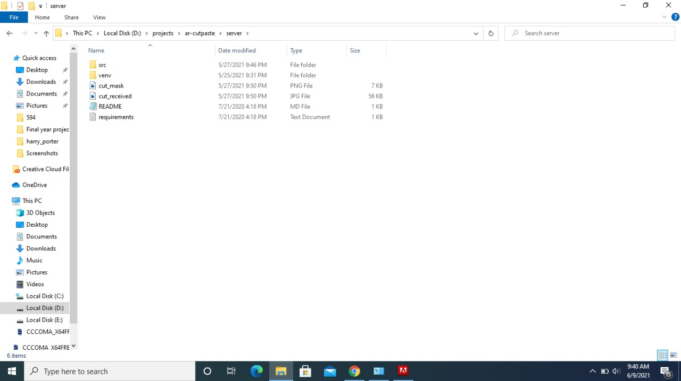 **8.RESULTS AND OUTPUTS**

**Fig.18** Path File

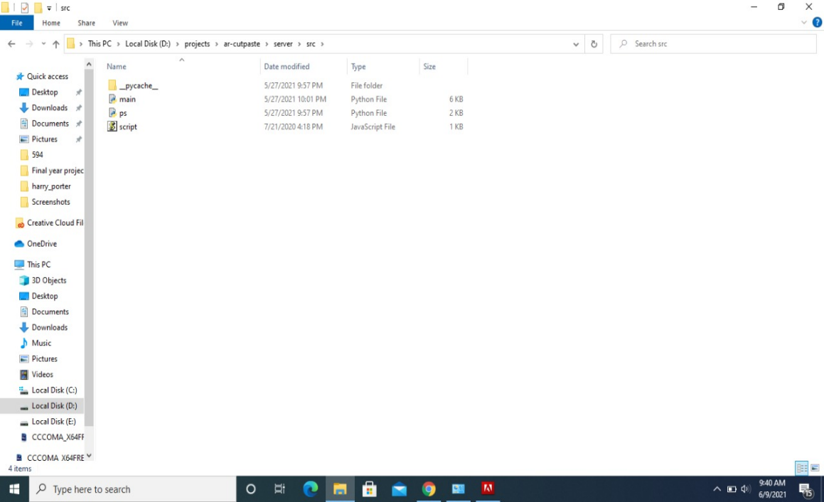

**Fig.19** Path File

**8.1 APP EXECUTION**

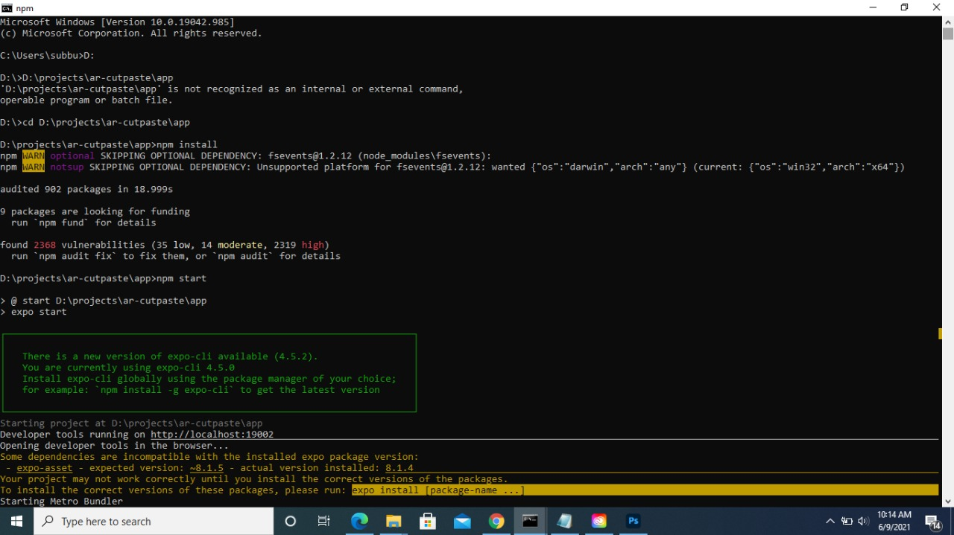

**Fig.20** App Execution

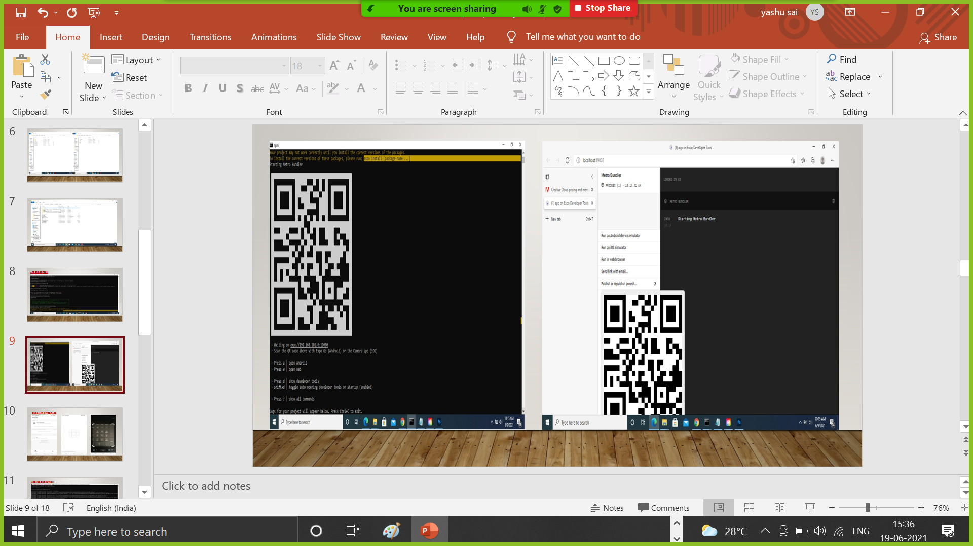

**Fig.21** QR Code Generator

**8.2 EXPO APP INTERFACE**

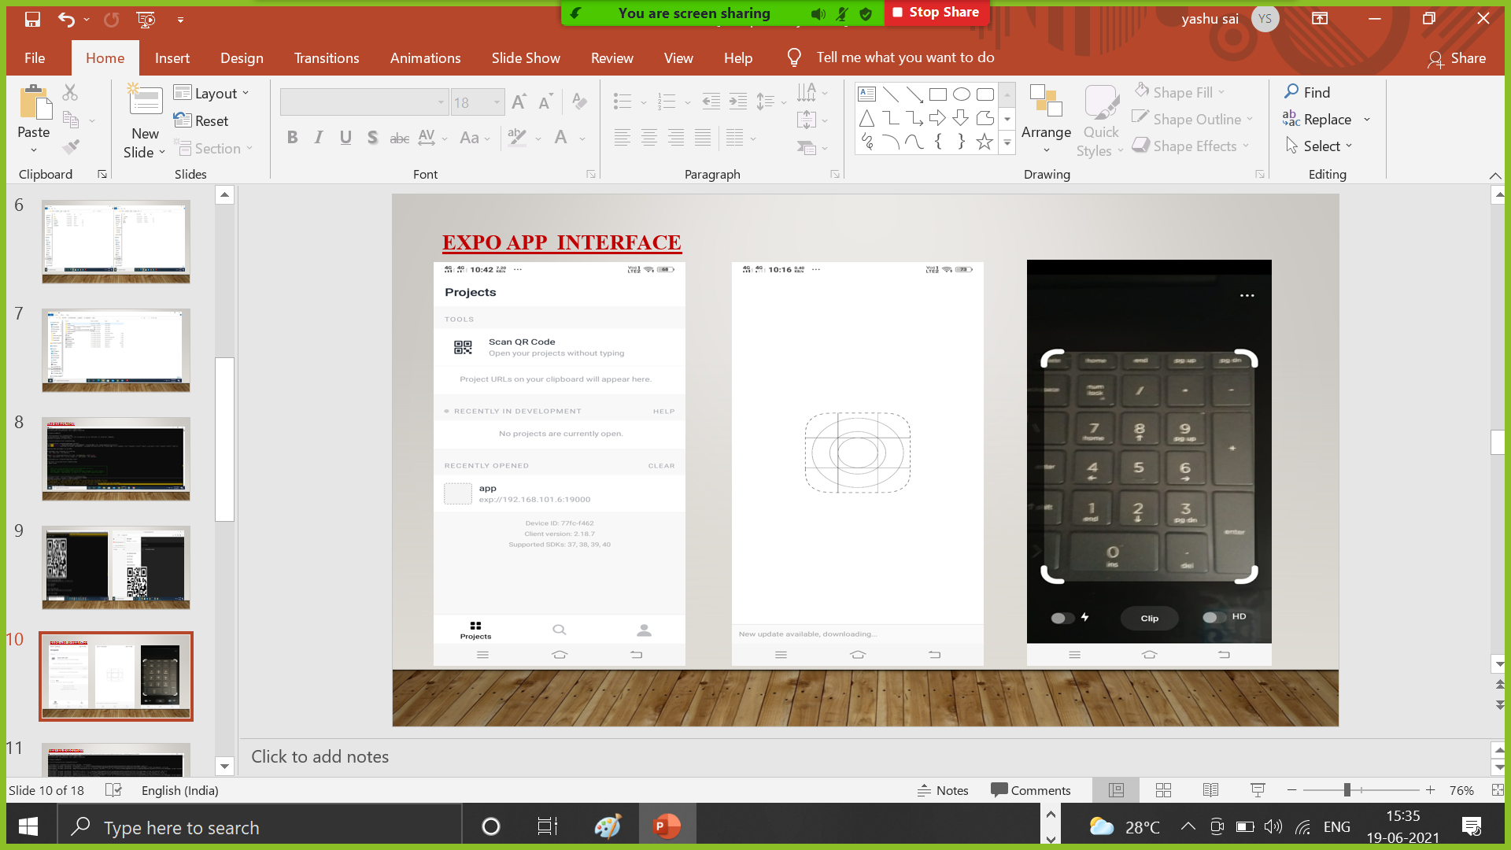

**Fig.22** App InterFace

**8.3 SERVER EXECUTION**

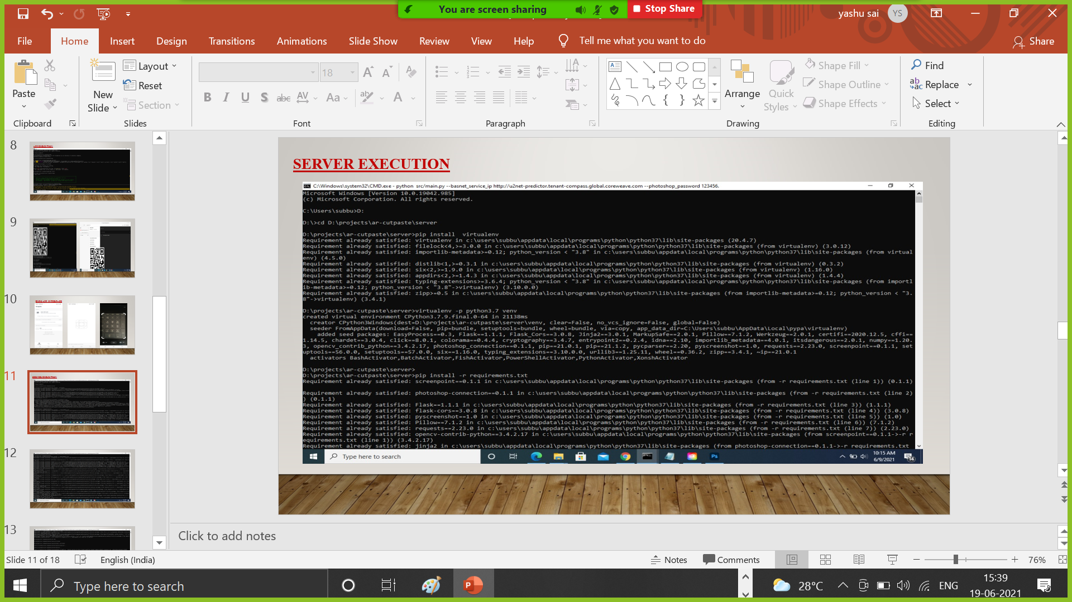

**Fig.23** Server Execution

**8.4 OUTPUT**

**8.4.1 Actual Output**

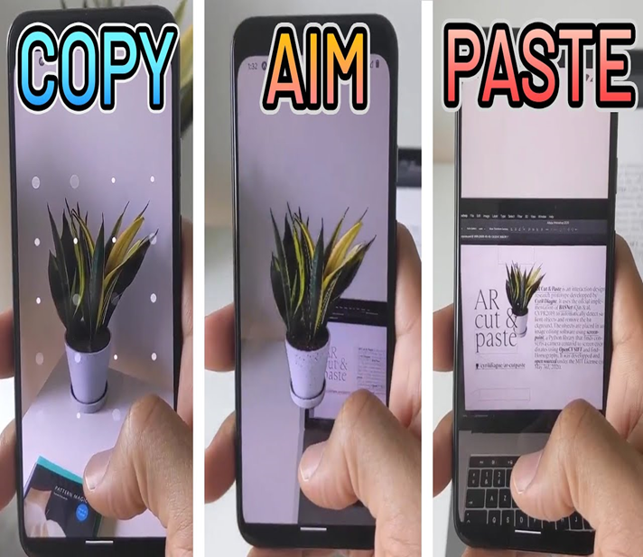

**Fig.24** Actual Output

**8.4.2 Expected Output**



**Fig.25** Expected Output

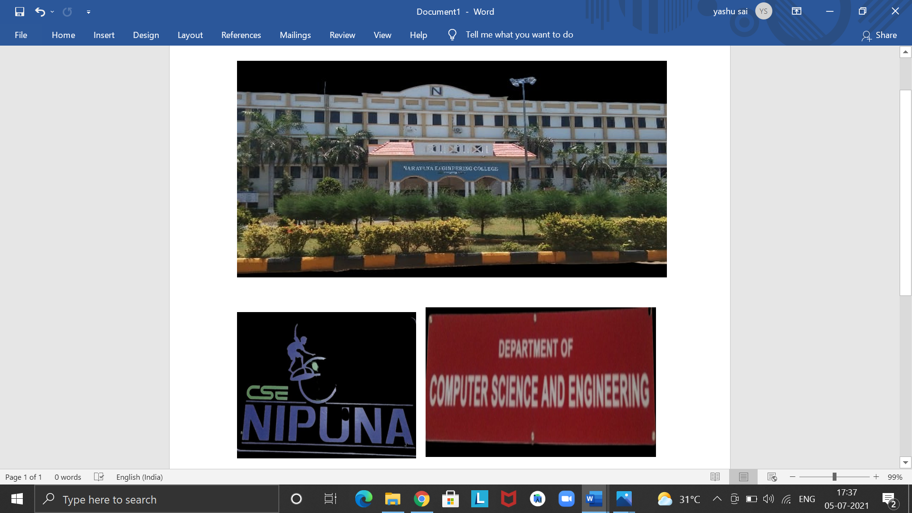

**Fig.26** Expected Output

**8.4.3 Practical Output**

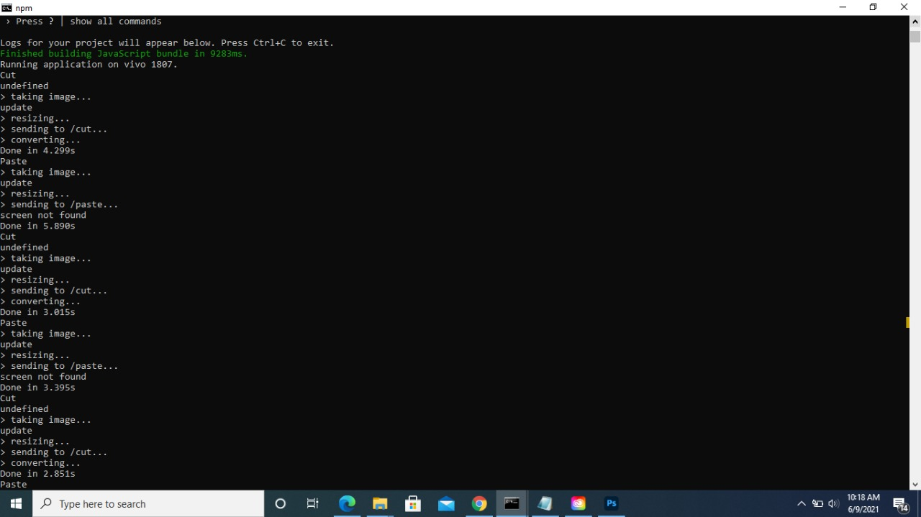

**Fig.27** Practical Output

**9.CONCLUSION**

Expanded Reality duplicate glue, subsequently isn't only an AR duplicate glue photoshop application however can have a horde of uses and augmentations. Simply the way applications like Whatsapp, Swiggy, Amazon have gotten imbued to our everyday way of life supplanting conventional messaging, Food orders, conveyance.

Expanded reality applications like Augmented Reality duplicate glue will not set aside much effort to turn out to be natural and again advise us that innovations have the responses to break our everyday confronted limits This work proposed an increased reality-based communication method for record move in numerous PC conditions. In particular, we give another connection procedure to numerous record move in non-truly co-found presentations.

This method might be simpler to utilize and more normal than customary procedures, because of the inescapability of cell phones and because of the way that the proposed strategy utilizes a few notable cooperation strategies (intuitive, tapping/tapping on documents) and cell phone capacities (applications, telephone camera)

**Future Scope**

If your tech is made open to this innovation like AR duplicate glue photoshop, it very well may be brought to various work spaces like printers or projectors, Augmented Reality can help print or venture a true article inside a couple of snaps and snaps. AR Copy Paste allows clients to snap a picture of an item in reality and drop the picture into a personal computer program with a couple of straightforward activities on their shrewd phon.

Make sure to arrange an alternate port in case you're running BASNet on a similar PC as the nearby help. Expo is a structure and a stage for all inclusive React applications is a bunch of apparatuses and administrations worked around React Native and local stages that help you create, fabricate, send, and rapidly emphasize on iOS, Android, and web applications from a similar JavaScript/TypeScript, codebase

**10.BIBILOGRAPHY**

[0] Dr.Cyrill Diagne , He is ML + HCL – Co-founder @initml Previously: Artist in residence @Googleartsculture Professor & Head of @ecal – mid , Co-founder of lab212.org

[1] R. Achanta, S. Hemami, F. Estrada, and S. Susstrunk. Recurrence tuned notable area identification. In 2009 IEEE Conference on Computer Vision and Pattern Recognition, pages 1597–1604, 2009.

[2] Ali Borji, Ming-Ming Cheng, Huaizu Jiang, and Jia Li. Remarkable item identification: A benchmark. IEEE Trans. Picture Processing, 24(12):5706–5722, 2015.

[3] Liang-Chieh Chen, George Papandreou, Iasonas Kokkinos, Kevin Murphy, and Alan L Yuille. Deeplab: Semantic picture division with profound convolutional nets, atrous convolution, and completely associated crfs. IEEE exchanges on design examination and machine insight, 40(4):834–848, 2017.

[4] Shuhan Chen, Xiuli Tan, Ben Wang, and Xuelong Hu. Invert consideration for remarkable item discovery. In Proceedings of the European Conference on Computer Vision (ECCV), pages 234–250, 2018.

[5] Jia Deng, Wei Dong, Richard Socher, Li-Jia Li, Kai Li, and Li Fei-Fei. Imagenet: A huge scope progressive picture data set. In 2009 IEEE gathering on PC vision and example acknowledgment, pages 248–255. IEEE, 2009.

[6] Zijun Deng, Xiaowei Hu, Lei Zhu, Xuemiao Xu, Jing Qin, Guoqiang Han, and Pheng-Ann Heng. R3net: Recurrent remaining refinement network for saliency discovery. In Proceedings of the 27th International Joint Conference on Artificial Intelligence, pages 684–690. AAAI Press, 2018.

[7] Marc Ehrig and Jer' ome Euzenat. Loosened up exactness and re-ˆ call for cosmology coordinating. In Proc. K-Cap 2005 workshop on Integrating philosophy, pages 25–32. No business manager., 2005.

[8] Deng-Ping Fan, Ming-Ming Cheng, Yun Liu, Tao Li, and Ali Borji. Design measure: another approach to assess forefront maps. In Proceedings of the IEEE Conference on Computer Vision and Pattern Recognition, pages 4548–4557, 2017.

[9] Mengyang Feng, Huchuan Lu, and Errui Ding. Mindful criticism network for limit mindful striking article location. In Proceedings of the IEEE Conference on Computer Vision and Pattern Recognition, pages 1623–1632, 2019.

[10] Xavier Glorot and Yoshua Bengio. Understanding the trouble of prepareng profound feedforward neural organizations. In Proceedings of the Thirteenth International Conference on Artificial Intelligence and Statistics, AISTATS, pages 249–256, 2010.

[11] Robert M Haralick, Stanley R Sternberg, and Xinhua Zhuang. Picture investigation utilizing numerical morphology. IEEE exchanges on design investigation and machine insight, (4):532–550, 1987.

[12] Kaiming He, Xiangyu Zhang, Shaoqing Ren, and Jian Sun. Deep residual learning for image recognition. In Proceedings of the IEEE conference on computer vision and pattern recognition, pages 770–778, 2016.

[13] Qibin Hou, Ming-Ming Cheng, Xiaowei Hu, Ali Borji, Zhuowen Tu, and Philip Torr. Deeply supervised salient object detection with short connections. In Proceedings of the IEEE Conference on Computer Vision and Pattern Recognition, pages 5300–5309, 2017.

[14] Xiaowei Hu, Lei Zhu, Jing Qin, Chi-Wing Fu, and PhengAnn Heng. Recurrently aggregating deep features for salient object detection. In AAAI, pages 6943–6950, 2018.

[15] Gao Huang, Zhuang Liu, Laurens van der Maaten, and Kilian Q Weinberger. Densely connected convolutional networks. In Proceedings of the IEEE Conference on Computer Vision and Pattern Recognition, pages 2261–2269, 2017.

[16] Diederik P Kingma and Jimmy Ba. Adam: A method for stochastic optimization. arXiv preprint, 2014.

[17] Alex Krizhevsky, Ilya Sutskever, and Geoffrey E Hinton. Imagenet classification with deep convolutional neural networks. In Advances in neural information processing systems, pages 1097–1105, 2012.

[18] Guanbin Li and Yizhou Yu. Visual saliency detection based on multiscale deep cnn features. IEEE Transactions on Image Processing, 25(11):5012–5024, 2016.

[19] Yin Li, Xiaodi Hou, Christof Koch, James M Rehg, and Alan L Yuille. The secrets of salient object segmentation. In Proceedings of the IEEE Conference on Computer Vision and Pattern Recognition, pages 280–287, 2014.

[20] Jie Liang, Jun Zhou, Lei Tong, Xiao Bai, and Bin Wang. Material based salient object detection from hyperspectral images. Pattern Recognition, 76:476–490, 2018.

[21] Chenxi Liu, Liang-Chieh Chen, Florian Schroff, Hartwig Adam, Wei Hua, Alan L Yuille, and Li Fei-Fei. Autodeeplab: Hierarchical neural architecture search for semantic image segmentation. In Proceedings of the IEEE Conference on Computer Vision and Pattern Recognition, pages 82–92, 2019.

[22] Jiang-Jiang Liu, Qibin Hou, Ming-Ming Cheng, Jiashi Feng, and Jianmin Jiang. A simple pooling-based design for realtime salient object detection. In Proceedings of the IEEE Conference on Computer Vision and Pattern Recognition, pages 3917–3926, 2019.

[23] Nian Liu, Junwei Han, and Ming-Hsuan Yang. Picanet: Learning pixel-wise contextual attention for saliency detection. In Proceedings of the IEEE Conference on Computer Vision and Pattern Recognition, pages 3089–3098, 2018.

[24] Jonathan Long, Evan Shelhamer, and Trevor Darrell. Fully convolutional networks for semantic segmentation. In Proceedings of the IEEE conference on computer vision and pattern recognition, pages 3431–3440, 2015.

[25] Shijian Lu and Joo-Hwee Lim. Saliency modeling from image histograms. In European Conference on Computer Vision, pages 321–332. Springer, 2012.

[26] Shijian Lu, Cheston Tan, and Joo-Hwee Lim. Robust and efficient saliency modeling from image co-occurrence histograms. IEEE transactions on pattern analysis and machine intelligence, 36(1):195–201, 2013.

[27] Zhiming Luo, Akshaya Mishra, Andrew Achkar, Justin Eichel, Shaozi Li, and Pierre-Marc Jodoin. Non-local deep features for salient object detection. In Proceedings of the IEEE Conference on Computer Vision and Pattern Recognition, pages 6593–6601, 2017.

[28] Ke Ma, Zhixin Shu, Xue Bai, Jue Wang, and Dimitris Samaras. Docunet: Document image unwarping via a stacked unet. In CVPR, pages 4700–4709, 2018.

[29] Ran Margolin, Lihi Zelnik-Manor, and Ayellet Tal. How to evaluate foreground maps. 2014 IEEE Conference on Computer Vision and Pattern Recognition, pages 248–255, 2014.

[30] Vida Movahedi and James H Elder. Design and perceptual validation of performance measures for salient object segmentation. In 2010 IEEE Computer Society Conference on Computer Vision and Pattern Recognition-Workshops, pages 49–56. IEEE, 2010.

[31] Alejandro Newell, Kaiyu Yang, and Jia Deng. Stacked hourglass networks for human pose estimation. In European conference on computer vision, pages 483–499. Springer, 2016.

[32] Adam Paszke, Sam Gross, Soumith Chintala, Gregory Chanan, Edward Yang, Zachary DeVito, Zeming Lin, Alban Desmaison, Luca Antiga, and Adam Lerer. Automatic differentiation in pytorch. In Autodiff workshop on NIPS, 2017.

[33] Xuebin Qin, Zichen Zhang, Chenyang Huang, Chao Gao, Masood Dehghan, and Martin Jagersand. Basnet: Boundaryaware salient object detection. In Proceedings of the IEEE Conference on Computer Vision and Pattern Recognition, pages 7479–7489, 2019.

[34] Olaf Ronneberger, Philipp Fischer, and Thomas Brox. Unet: Convolutional networks for biomedical image segmentation. In International Conference on Medical image computing and computer-assisted intervention, pages 234–241. Springer, 2015.

[35] Karen Simonyan and Andrew Zisserman. Very deep convolutional networks for large-scale image recognition. arXiv preprint arXiv:1409.1556, 2014.

[36] Christian Szegedy, Wei Liu, Yangqing Jia, Pierre Sermanet, Scott Reed, Dragomir Anguelov, Dumitru Erhan, Vincent Vanhoucke, and Andrew Rabinovich. Going deeper with convolutions. In Proceedings of the IEEE conference on computer vision and pattern recognition, pages 1–9, 2015.

[37] Zhiqiang Tang, Xi Peng, Shijie Geng, Lingfei Wu, Shaoting Zhang, and Dimitris Metaxas. Quantized densely connected u-nets for efficient landmark localization. In Proceedings of the European Conference on Computer Vision (ECCV), pages 339–354, 2018.

[38] Zhiqiang Tang, Xi Peng, Shijie Geng, Yizhe Zhu, and Dimitris N Metaxas. Cu-net: coupled u-nets. arXiv preprint arXiv:1808.06521, 2018.

[39] Lijun Wang, Huchuan Lu, Yifan Wang, Mengyang Feng, Dong Wang, Baocai Yin, and Xiang Ruan. Learning to detect salient objects with image-level supervision. In Proceedings of the IEEE Conference on Computer Vision and Pattern Recognition, pages 136–145, 2017.